CARA planner
The CARA planner must be used by staff when developing a unit plan within the three levels of planning. The CARA planner assists staff to identify the potential hazards, the inherent risk level and control measures for curriculum activities. If a CARA guideline exists for the activity it must be used in conjunction with the CARA planner.
Further information about planning, is found in the Managing risks in school curriculum activities procedure and the CARA generic template.

CARA risk matrix
The CARA risk matrix is used to assist in determining risk levels of curriculum activities. Consider each hazard in terms of the likelihood of an incident occurring in conjunction with the consequence (or injury) if the incident did occur.

INHERENT RISK = Consequence if an incident were to occur x Likelihood of an incident occurring before any control measures are put in place.
 |  | Injury requiring no treatment. | Injury requiring first aid treatment. | Injury requiring medical treatment | Injury requiring specialist medical treatment or hospitalisation. | Injury resulting in loss of life or permanent disability.
 | 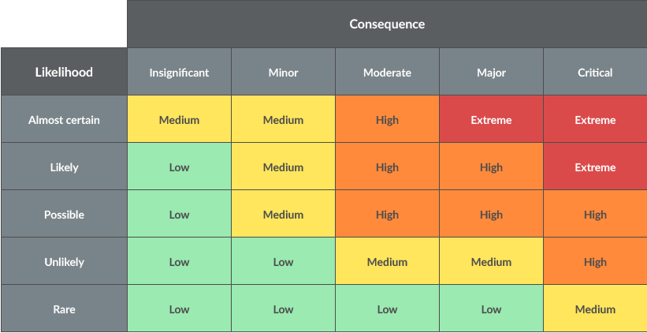
Expected to occur in most circumstances
Will probably occur in most circumstances
Might occur occasionally
Could happen at some time
May only occur in exceptional circumstances

Additional information about three levels of planning, aligned to the Australian Curriculum achievement standards, is available in the P-12 curriculum, assessment and reporting framework, the supporting document Assessment and moderation in Prep to Year 10, and the Assessment and Moderation Hub. ² The CARA Risk Matrix is found on Page 2. ³ The CARA flowchart can be found on the Policy and Procedure website

