Asbestos in leased facilities checklist

This form is used to:
- record information obtained and decisions made about the selection of facilities for leasing (in regard to presence of asbestos containing materials (ACM)); and
- confirm the inclusion of mandatory asbestos-related provisions in documented lease agreements for leased facilities that contain ACM.
Note: hold point after section 2 before proceeding to completion of section 3.

Section 1 – Facility information
Facility name/address:
Reason for lease:
Person requesting lease:
Record completed by: | Insert name and title of person responsible for selecting facilities for leasing

Facility with no assumed or confirmed asbestos | ACM leased facility
The following sources of information have been provided by the facility owner in relation to asbestos presence (check all that apply):  Asbestos register identifying that all previous ACMs have been removed from the facility  Record of asbestos survey or inspection indicating no ACM present in the facility  Build details indicating the building was constructed post 1 January 1990 and does not contain plant or equipment that was manufactured prior to 31 December 2003. | The following sources of information have been provided by the facility owner in relation to asbestos presence (check all that apply):  Asbestos register identifying assumed or confirmed ACM  Record of asbestos survey or asbestos condition inspection indicating presence of ACM  Asbestos management plan prepared by the facility owner and reviewed within the last 5 years  Build details indicating the building was constructed prior to 31 December 1989 or contains plant or equipment that was manufactured or imported prior to 31 December 2003  or  Facility owner has not provided an asbestos register and has not been able to produce evidence to support reasonable grounds to believe ACM is not present at the facility
If one or more boxes are ticked  no further completion of checklist is required. Ensure records of the information sources are filed with the lease documents.  (Asbestos management in facilities leased for departmental use procedure does not apply) | (Asbestos management in facilities leased for departmental use procedure applies)

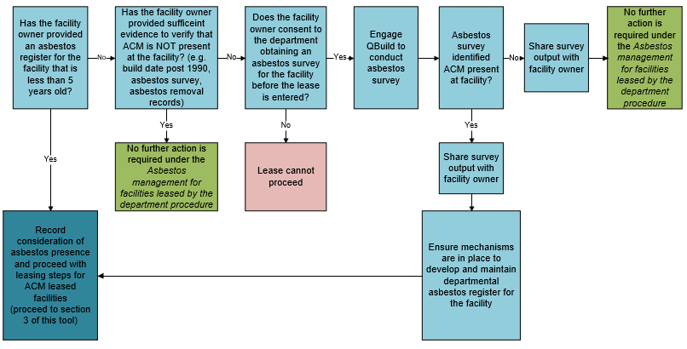

Section 2 – Facility asbestos information
Asbestos-related records provided by facility owner
Title | Version/date
e.g. asbestos register | e.g. Rev.5, 18 Aug 2025

Additonal information for consideration by lease executor
- Have alternative asbestos-free facilities been considered? | Yes  No | Outcome:
- Have alternative asbestos-free facilities been considered? | Yes  No | Insert conclusions about the alternatives
- Has the facility owner provided an asbestos register that identifies the:  - date on which the ACM was identified;  - location of the ACM;  - type of ACM; and  - condtion of ACM | Yes  No | If yes, skip to question d.
 | Yes  No | If no, the department will be required to engage QBuild to establish an asbestos register.
- Has the facility owner given permission for the department to arrange access for an asbestos survey to be conducted? | Yes  No  N/A | If yes, engage QBuild to conduct an asbestos survey
 | Yes  No  N/A | If no, lease must not be executed.

- Does the asbestos register or asbestos survey identify ACM that is in poor or hazardous condition? | Yes  No | Details:
 | Yes  No | Insert relevant information
 | Yes  No | If yes, list controls proposed to mitigate risks to the facility community, should the lease proceed.
 | Yes  No | Insert controls
- Does the asbestos register or asbestos survey contain recommended asbestos management actions that have not been carried out or scheduled? | Yes  No | Details:
 | Yes  No | Insert relevant information
 | Yes  No | If yes, list controls proposed to mitigate risks to the facility community, should the lease proceed.
 | Yes  No | Insert controls

Hold point – section 1 and 2 quality control

Director, Infrastructure Safety, considers the information completed for section 1 and 2 of this checklist has sufficient regard for the presence and future management of asbestos at the facility.
Name:
Date:
Checklist comments: | Insert as appropriate

Section 3 – Lease inclusions
Prior to signing a lease for a facility that is known to contain asbestos, confirm a request has been made to include the following information in the documented lease agreement between the department and the facility owner.
Item | Requested (Y/N) | Included  (Y/N) | If yes, relevant section/clause
The documented agreement details responsibilities for the facility owner to provide to the department, the following information:
- Details of asbestos presence (e.g. through provision of asbestos register)
- How the facility owner manages the asbestos (e.g. their Asbestos Management Plan)
- Updates to condition or status of ACMs at the facility (e.g. after condition monitoring)
- How the facility owner will notify the department of planned works
- Timeframes for updates (e.g. asbestos register provided annually)

The documented agreement details responsibilities for the department to provide to the facility owner, the following information:
- Asbestos condition details and updates (e.g. deterioration or damage reports)
- How the department will notify the facility owner of planned works
- Issues with ACM labels or warning signage provided by the facility owner
The documented agreement specifies:
- The agreement required for the department to execute the selected label approach (where labels have already been placed in the facility)
- Works the department is responsible for (e.g. refurbishment or fit out, repair of damage, general maintenance).
- Works the facility owner is responsible for (e.g. refurbishment, repair of damage, general maintenance).
- Works the department is permitted/prohibited from undertaking or commissioning. (e.g. building layout changes, repair of damage)
- Methods for obtaining of permission from the facility owner to undertake or commission works.
- How negotiations will be carried out in circumstances where planned works may result in operational disturbance (e.g. asbestos removal work requires facility community to be relocated if conducted during operating hours)
- That a work area access permit will be issued to all service providers prior to the commencement of facility works (whether engaged by the department or the facility owner).

Select relevant category based on lease inclusions listed above and obtain approval at specified level.

Category A  All requested inclusions have been addressed in the documented lease agreement?  (low risk)  Progress to lease execution | Category B  Some requested inclusions have not been captured in the lease agreement and the following mitigation strategies have been established to manage risk  (medium risk) | Category C  Some requested inclusions have not been captured in the lease agreement and no additional risk mitigation options are available  (high risk)
 | Mitigation strategies:  Insert | Comments:  Insert
 | Approval level: Manager | Approval level: Lease executor
 | Name: Insert  Position: Insert  Date approved: Insert | Name: Insert  Position: Insert  Date approved: Insert

Checklist completion details
Name:
Role:
Date:
Lease CM ref:

In line with work health and safety legislation, it is acceptable to assume that a building constructed from 1 January 1990, which does not have any plant or equipment that was manufactured and imported prior to 31 December 2003 (for example, kilns, tractors, generators, heater banks) does not contain asbestos. Neither an asbestos survey or asbestos register is necessary for these buildings. For buildings constructed up to 1 January 1990, or where facilities contain plant or equipment that were manufactured and imported prior to 31 December 2003, the determination about the presence of asbestos must be made based on the facility owner’s asbestos register.
The departmental representative with Delegation of Minister's Powers under the Constitution of Queensland 2001, for Real Property.
the Work Health and Safety Regulation 2011 (Qld) requires a person with management or control of a workplace to ensure an asbestos register is prepared, maintained and kept at the workplace

