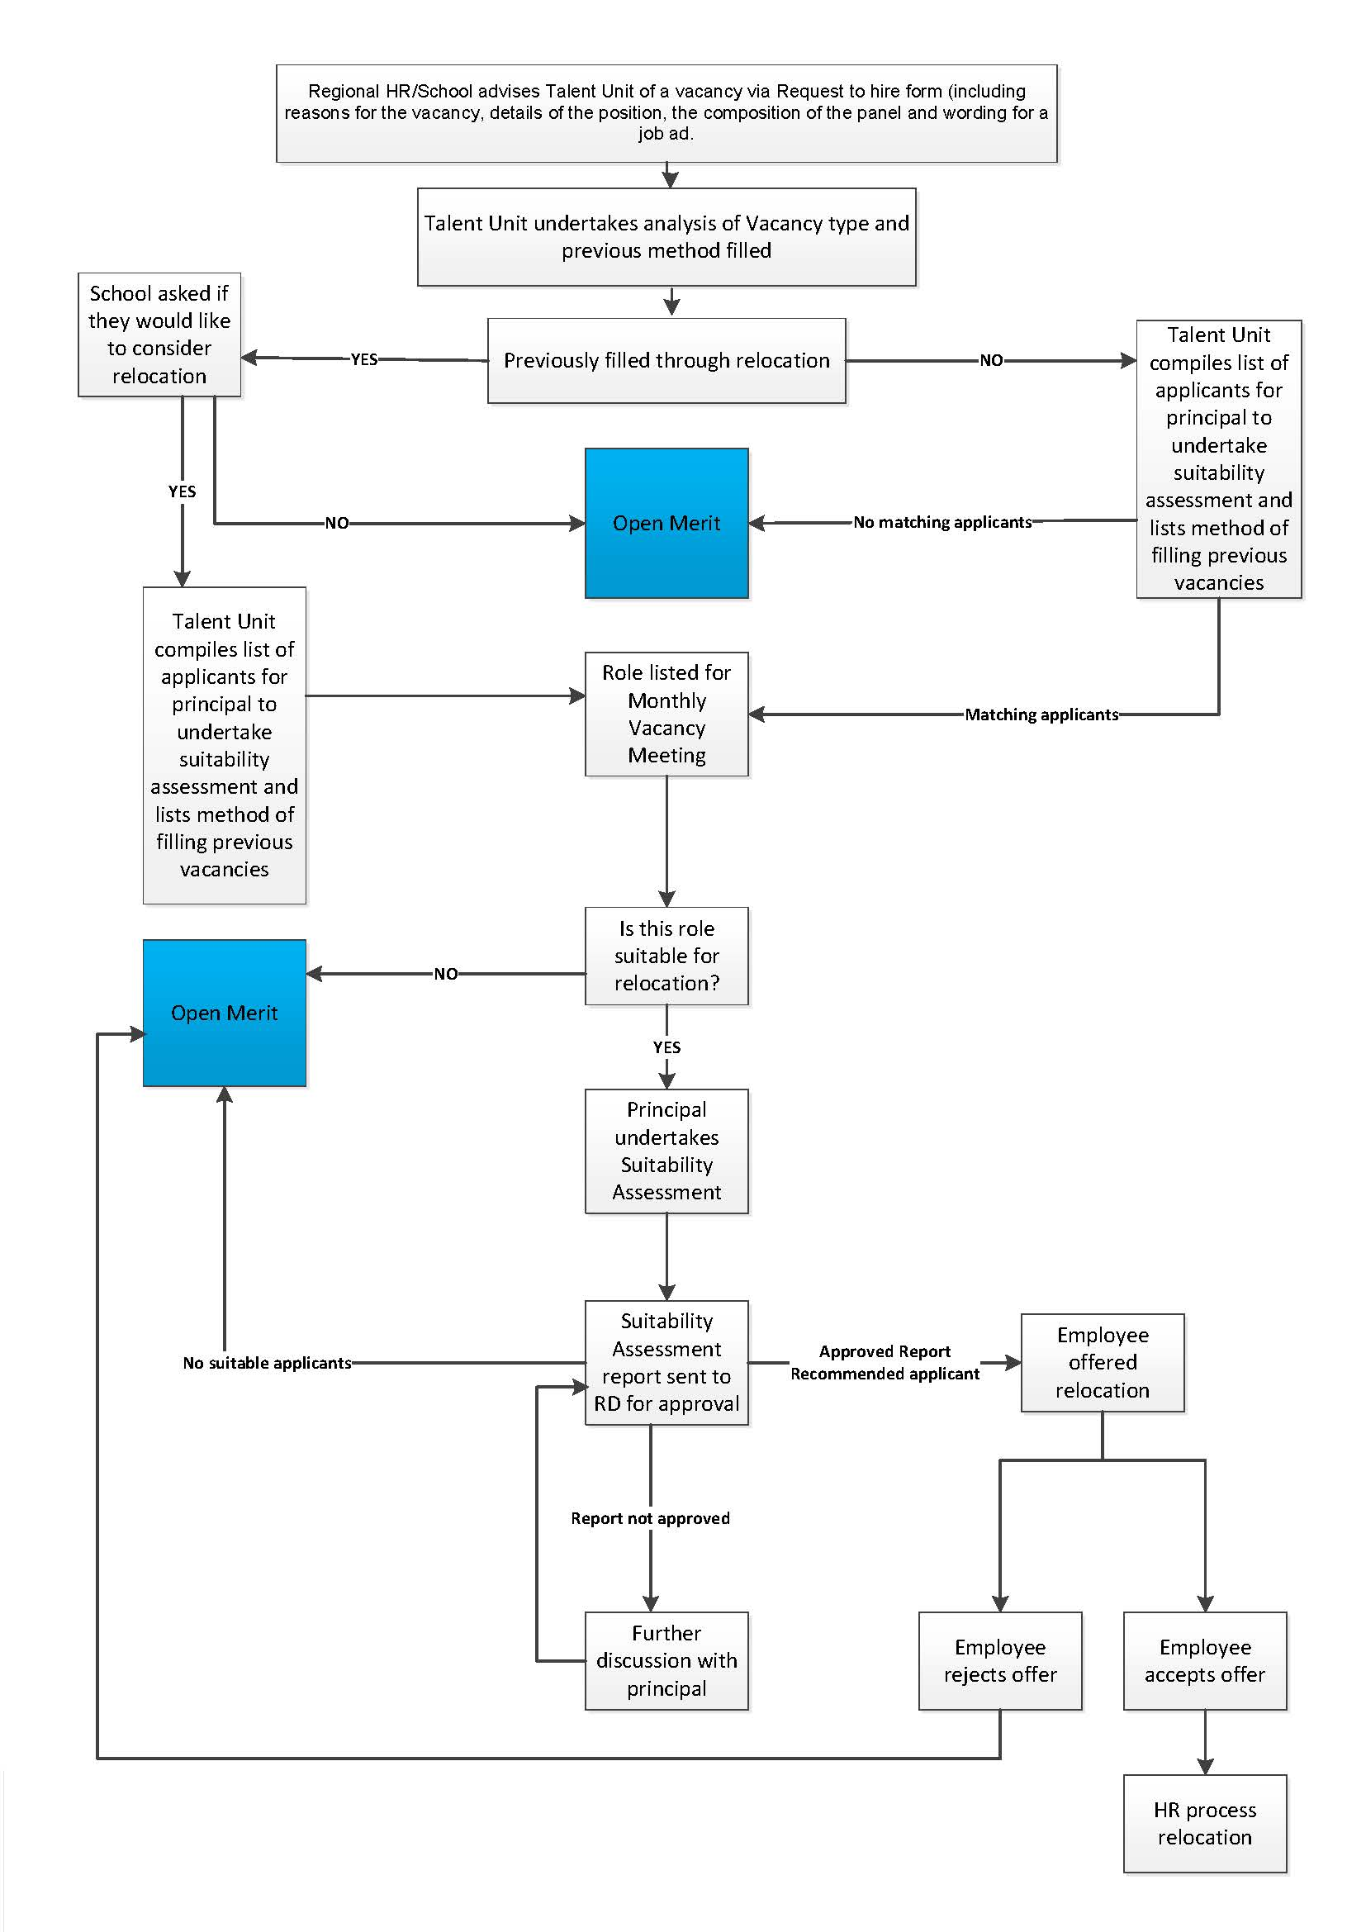

**Read in conjunction with the** [**Recruitment of classified teacher positions (school leaders and heads of program)**](https://ppr.qed.qld.gov.au/pp/recruitment-of-classified-teacher-positions-school-leaders-and-heads-of-program-procedure) **procedure.**

**Uncontrolled copy.** Refer to the Department of Education Policy and Procedure Register

at <https://ppr.qed.qld.gov.au/pp/recruitment-of-classified-teacher-positions-school-leaders-and-heads-of-program-procedure> to ensure you have the most current version of this document.

Classified teaching recruitment (excluding principals) flowchart