Customer complaints management – Internal review information sheet
This document is provided as a supporting resource to the Customer complaints management – Internal review procedure.

What is an internal review?
An internal review is a process a complainant can request which examines if the complaint management process for a customer complaint was appropriate and/or if the outcome reached was reasonable. An internal review is not a re-investigation of the original customer complaint.

How to request an internal review
You can request an internal review by submitting a request for internal review form or calling the department and requesting an internal review over the phone.
You must explain why an internal review is appropriate (for example, why the original decision was unreasonable or the complaint handling process was unfair or deficient) and what action you would like taken to resolve the issue. If insufficient information is provided, the internal review request may be declined.
You must lodge your request within 20 days of receiving a complaint outcome. If the original complaint was managed by a school, the internal review request should be lodged with the regional office. All other requests should be lodged with the area that responded to the original customer complaint.

Who conducts an internal review?
An internal review is conducted by departmental staff who are independent from the original complaint. The internal review officer is trained to handle internal review matters and is authorised to make decisions and recommendations about the customer complaint.

How is an internal review conducted?
Internal reviews are conducted in accordance with the following process:
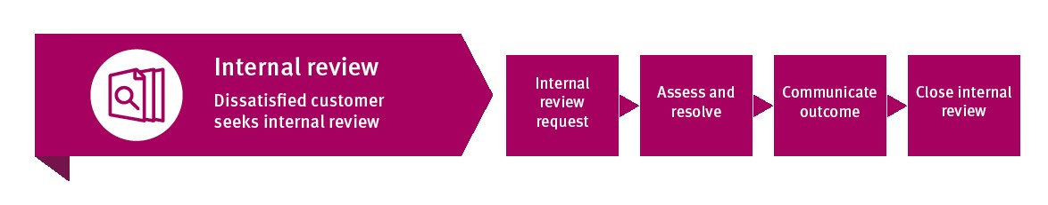
The internal review officer will analyse the original complaint to determine if the complaint management process and/or outcome was appropriate by considering and assessing:
- information provided with the internal review request
- material considered as part of managing the original customer complaint
- if the customer complaints management procedure was followed
- human rights; and
- other information from relevant parties (for example, original complaints officer or complainant).
The internal review officer will write to you to let you know the outcome of the internal review. This should occur within 20 days, although this depends on the complexity of the internal review. If the internal review will take longer than 20 days, advice will be provided to you.
The Internal review procedure contains more information about the department’s approach to internal reviews.

What if you are still dissatisfied after an internal review?
You may seek an external review. This is a process conducted by an external review body, such as the Queensland Ombudsman, Queensland Human Rights Commission or other relevant authority, that ensures the department’s decision-making was fair, reasonable and proper.

