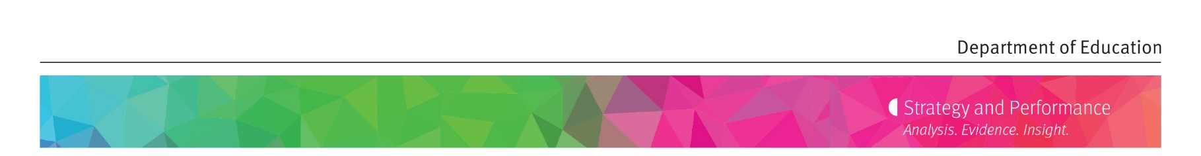
Information sheet 5

Ideas, innovation and risk

Considering a new idea or activity?
New ideas, innovation and opportunities may have a large impact on improving outcomes for children, young people and communities. New and innovative ideas may resolve a local issue or could be more broadly applied across the department’s activities. When considering a new idea or activity, also consider the risks that may occur before, during and after the activity commences.
Risks should not prevent you from considering a new idea or innovation. Instead it should allow you to consider all risks associated with the activity to help make an informed decision about how you should proceed.
The department monitors risks that may impact the achievement of strategic objectives according to the department’s risk appetite. The department has the lowest appetite for risks associated with:
- safety of children and students
- workplace health and safety of its staff and the community
- security of confidential and personal information held by the department
- fraud and corruption.
To foster new ideas, the department is willing to accept a higher level of risk when pursuing innovation and opportunities that further its strategic objectives to give all children a great start, engage young people in learning and creating safe, fair and productive workplaces and communities. The complexity of the operating model and environment will influence the level of risk the department is willing to accept.
When considering new ideas or initiatives, consideration must be given to:
- the level of risk (or opportunity) the decision or activity will create
- whether the proposed level of risk (or opportunity) aligns with the department’s risk appetite
- what actions or controls can be taken to reduce the impact of the risk to an acceptable level (or to maximise the opportunity).
The following questions or checklist may help you to consider the risks for your new idea or activity before, during and after commencement of the activity:
Risk checklist considerations: | Yes/No
Operational
Operational risks of conducting this new activity have been considered?
Operational risks of not conducting this new activity have been considered?
Are there any legal reasons why the activity cannot go ahead? i.e. is the activity legal?
Child or student safety
Child or student safety considerations for this activity have been considered?
Is there a risk of failing to comply with legislative requirements for child protection resulting in a preventable risk, harm or death of a child?
Can strategies (controls and actions) be implemented to reduce the any potential risk to children or students’ safety?
Workplace health and safety
Workplace health and safety (WHS) requirements of this activity for departmental staff and the community have been considered?
Could the activity result in:
- physical or mental harm to staff, students and others

- adverse impact on school or workplace operations
- damage to DoE infrastructure and property
- damage to the natural environment
- regulatory or other legal action against the Department or individual
- reputational damage to the Department
- financial penalties or increased operational costs?
Can strategies (controls or actions) be implemented to reduce any potential WHS risks?
Information security
Could the activity lead to unauthorised access to and/or use of departmental data or information?
Could access to departmental data or information result in financial and/or reputational loss or privacy breaches for the department?
Can strategies (controls or actions) be implemented to reduce any potential information security risks?
Fraud and corruption
Will the activity adversely expose the department to fraud and corruption through misuse of data, information or access to systems?
Can strategies (controls and actions) be implemented to reduce any potential fraud and corruption risks?
Overall
Can the Principal’s Risk Control Checklist be applied to this activity to reduce the likelihood or consequence of the risks identified?

