Disaster and Emergency Management
Response Team Roles and Responsibilities
When the Department’s disaster and emergency management arrangements are implemented, there is a requirement for each level (Executive, Regional or School) to form a Response Team. This forms part of the temporary organisational and reporting structure for a designated period. The Department’s Response Structure is as follows:

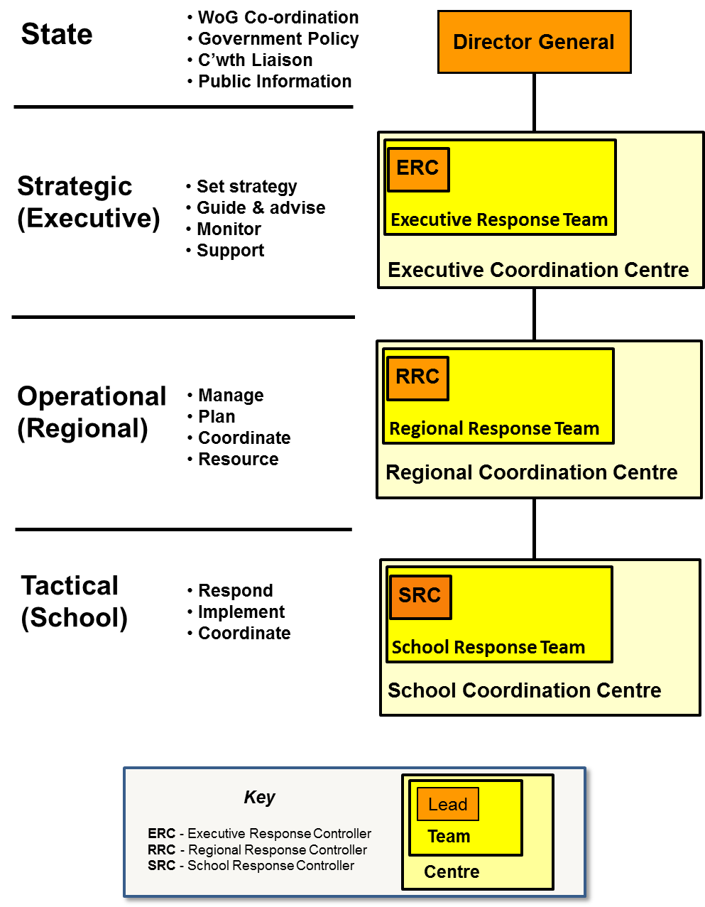

The Response Teams are the Department’s operational and decision making authority at their requisite level. They are activated and chaired by the Response Controllers. These Teams should have arrangements in place to enable a close working relationship with other relevant DET Response Teams,
DET areas and any external supporting agencies. The mechanism for coordination activities with other agencies will be via the Operations function, or via an Advisory Group, if the complexity of the event requires the formation of such a group. The scale of the activation of the Response Team will be determined by the Response Controller.

The Teams will be comprised of experienced officers of the department who are competent to undertake their required roles either by the alignment of their current duties or their training.

Response Team levels and leadership

Level | Team | Officer-in-Charge | Designated Officer
Executive  (Strategic) | Executive Response Team (ERT) | Executive Response Controller (ERC) | Assistant Director-General - Infrastructure Services Branch
Region  (Operational) | Regional Response Team (RRT) | Regional Response Controller (RRC) | Regional Director
School  (Tactical) | School Response Team (SRT) | School Response Controller (SRC) | School Principal

Response Team Structure
The structure of the Response Team will vary depending on level, location, available resources, the scale of the disaster or emergency event and the severity of the impact. In general, to ensure a location can respond effectively in a disaster or emergency event, the following areas of responsibility could be considered when developing the structure of the Response Team.

As part of the emergency management planning for each level and location, the staff who will be assigned the recommended roles and responsibilities should be identified and included in the Emergency Response Plan (ERP). These roles may have some variation across the levels of the response.
The format of the structure supports and aligns to other disaster management entities e.g. within the State Disaster Management Arrangements, the Emergency Services and Local Government structures.
Executive/Region/School Response Team Roles

The composition of Response Teams will vary and below is a table outlining the possible functional areas and their roles. As mentioned, the Response Controller will determine which functions are required during a specific response.

Function | Role
Response Controller | Overall lead and coordinator of the disaster or emergency response and recovery.
Operations | To provide support to ERC and RRC  To manage and task additional resources to support operations.  To manage the staff deployments to the SDCC and overview the flow of information to, and from, the SDCC.  To manage the deployment of staff to other agencies as required.
Intelligence | To collate, analyse and display information and intelligence to support situational awareness and decision making.  To prepare Briefs and internal SITREPS as required
Logistics | To securing resources and external services to support and sustain response operations and assist in the restoration of educational services.  To supports the other functional areas through the financing of response operations as necessary and to recording expenditures.  To provide administrative support and management of the Coordination Centre.
Communication | To manage the development of communications and briefs and subsequent of information across the Department and externally during the response to a disaster or emergency.
Finance | Supports the other functional areas through the financing of operations as well providing administrative support and management of the Coordination Centre. Responsible for tracking of response costs for corporate accounting.
HR and Wellbeing | Conduct activities to support staff resilience. Monitoring the management of risk, welfare safety of all staff through the advice on entitlements, welfare and wellbeing support.
Advisory Group | Senior or Specialist staff or stakeholders who provide advice and guidance to the Response Controller.

