This form is to be read in conjunction with the flexible work arrangements procedure when the flexible work arrangements request includes telecommuting (working from a location other than a Department of Education office).

This self-assessment is designed to help you set up your computer workstation in accordance with best practice guidelines. Please note any other medical advice must be followed if different to the generic ergonomics principles. Complete this form and attach it to your application for a flexible work arrangement.

The form will be reviewed by your manager so any risks can be identified and actions taken as needed prior to agreeing to a flexible work arrangement.

Telecommuting self-assessment

Name: |  | Location address:
Position: |  | Telephone number:
Work unit: |  | Mobile number:
Division: |  | Emergency contact:
Description of home based office (define area where work will occur):

Please attach photos of the following areas (optional):
□ Work area
□ Desk and chair
This document is designed to help you set up your computer workstation in the best way possible according to best practice guidelines. Sitting comfortably may lower stress and reduce the potential for injuries caused by repetitive computer work and awkward postures.
Note that the advice provided is of a generic nature and is not prescriptive. The most important thing is that you are comfortable at work. If you are experiencing discomfort, do not persevere and do not be afraid to make changes to your setup. If you share your desk with others always adjust your workstation to suit at the start of the work day.
Regardless of how well your computer and desk is set up, you should move often! The Heart Foundation suggests:
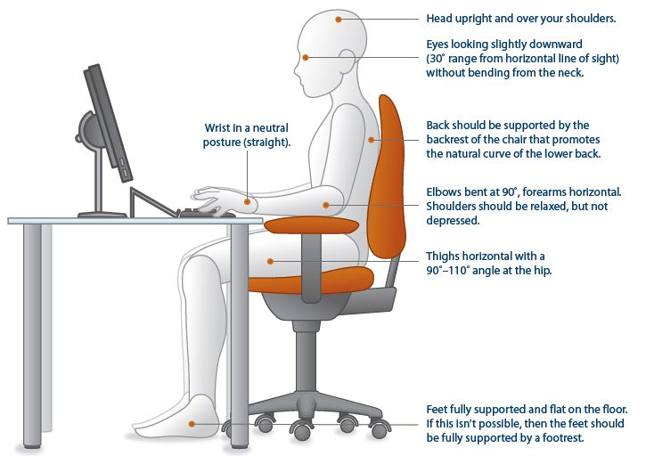
- Taking regular breaks from your computer. Get up and take a break every 30 minutes.
- Rotating standing tasks and sitting tasks across your shift.

Some examples of how you can stay active at work and cut down your sitting time include:
- Standing often – even for a few seconds at a time.
- Have lunch and morning and afternoon tea away from your desk.
- Stand to retrieve folders and files off shelves in your workstation.
- Stand when you are on the phone (a headset or speaker phone can make it easier).
- If you have to sit during long phone conversations, stand periodically.
- Drink more water and walk to refill your glass or water bottle.
- Move your bin away from your desk so you have to get up to use it.
- Vary your tasks through the day so that you change your posture and use different muscles e.g. do some filing after a period of typing.
- Stretch regularly (refer to the department’s ‘Daily stretches for staff’ poster).

It is not necessary to purchase a sit stand workstation to improve your posture and decrease risks of sedentary work. Getting up from your desk regularly can be just as effective to create a change in posture and burn calories. You can try to get in to the habit of sitting less by setting reminders on your phone or computer.
Postural comfort
Study the diagram above showing good posture in sitting. Setting up your workstation to imitate this will go a long way towards minimising your risk of discomfort and injury at your desk.

Self-assessment checklist
- Remember, the aim is to set yourself up so that you achieve a good natural sitting posture but you must regularly move for your health!
- Read each section carefully and tick yes, no or not applicable to each question. For additional advice, refer to the Office ergonomics guideline.
- Be sure to return the completed form to your supervisor/manager and discuss any actions or requirements with them.

1 | Your work surface/desk  It is important to position your computer appropriately to optimise the space available while ensuring good postures are maintained. To begin with, your desk should be smooth and flat with your keyboard and mouse on the same level. | Yes | No | N/A | Suggested Actions/Notes
1.1 Is your desk height adjustable?  If yes, then sit back in your chair with your feet flat on the floor, your knees slightly lower than your hips and your elbows by the side of your body bent like an L-shape. Adjust the desk height so that your forearms rest on it parallel to the floor (see diagram on page 2). |  |  |  |  | - Adjust desk height accordingly  - If non-adjustable, adjust your chair according to the guidelines in section 2: “Your chair”.
1.2 Are you sitting facing the desk straight on with sufficient forearm support?  Aim to sit with your stomach parallel to the edge of the desk to avoid twisting your back and neck. Try to get close enough so that you have enough desk space to rest your wrists/forearms on between spells of typing (roughly 7 to 15cm from the edge of the desk and your keyboard). If your desk is scalloped shaped (curved cut-out), sit so that your forearms have equal support on either side. |  |  |  |  | - Adjust orientation of self/desk items accordingly.
1.3 Is there sufficient room under your desk for you to comfortably stretch your legs?  Ensure there are no obstructions under your desk making you straddle or causing you to sit with both legs to one side therefore twisting your body. Avoid crossing your legs. |  |  |  |  | - Remove obstacles from under your desk.  - Move your setup to somewhere without obstruction where possible.
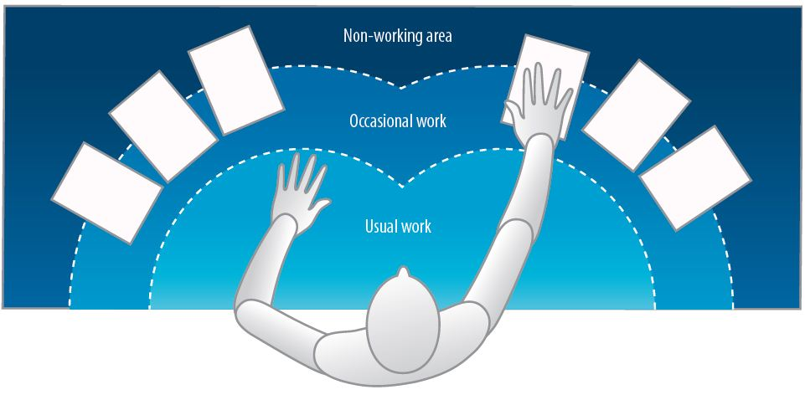  1.4 Are frequently used items in the “usual work” zone and occasionally used items in the “occasional work” zone (see diagram)?  Determine what items are used ‘occasionally’ or ‘usually’ on your desk e.g. your phone, sticky notes, stapler, water etc.  to avoid overreaching. |  |  |  |  | - Re-arrange workstation
2 | Your Chair  A comfortable chair that is in full working order is essential to a good setup. If there are levers and knobs on your chair (usually underneath), don’t be afraid to use them! To be effective, the chair needs to be adjusted to suit you and allow you to maintain the natural “S-curve” of the back. | Yes | No | N/A | Suggested Actions/Notes
2.1 Can the height of your chair be adjusted?  Adjust the height of your chair so that when your shoulders are relaxed (elbows by your sides), your forearms rest horizontally on the desk with your elbows bent like an L-shape and your knees are slightly lower than your hips (refer to diagram on page 2). |  |  |  |  | - No adjustment option to suit you? Obtain/use an alternative chair with adjustable height – test other chairs to identify suitable options. If you are going to purchase a new chair trial it first before purchasing from a supplier.
2.2 Are your feet fully supported by the floor when you are seated?  After you have adjusted the chair height as recommended above, check whether your feet are still flat on the floor. |  |  |  |  | - Feet not flat after chair adjustment? Obtain and use a footrest.
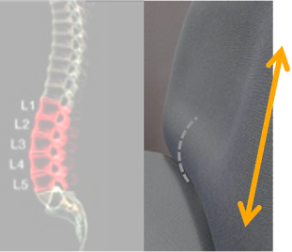  2.3 Is the height of your chair’s backrest adjustable?  Run your hand down the backrest until you feel the lumbar support (protruding part). You should be able to adjust the height of the backrest so that this lumbar support fits snuggly into the natural curve of your lower back allowing you to maintain the “S-curve”. Secure in place when satisfied. |  |  |  |  | - No adjustment option to suit you/back rest no longer adjustable? Obtain an alternative chair with adjustable backrest height – see notes above about trials.  - If no/inadequate lumbar support consider a lumbar roll.
2.4 Is your back at a comfortable angle with adequate support?  Sit with your bottom as far back in the chair as you can to achieve the desired 90° – 110° angle at the hip. Ensure your back rests comfortably against the back of the chair for adequate support. |  |  |  |  | - Inadequate support? Consider a chair with a larger/alternative backrest.
2.5 Is there a 2–3 finger-width gap between the back of your knees and the seat edge?  Not enough support under the thighs (i.e. the gap is greater than 2–3 fingers width) will cause discomfort and too much pressure (i.e. the chair is pressing on the back of your knee) may affect circulation. |  |  |  |  | - Seat pan too deep? Consider a back support to reduce depth or a chair with a shallow seat pan. Too shallow? Obtain/use an alternative chair with deeper seat pan.
2.6 Do your armrests allow you to get close to your workstation?  If the chair has armrests and you like using them make sure they are adjusted to elbow height with your shoulders relaxed. They must not prevent you from sitting close to the edge of the desk or restrict natural movements. |  |  |  |  | - Adjust armrests.  - Remove armrests if impeding movement or if preferred.
3 | Your monitor/s  Sizes of monitors can vary greatly and there is a growing trend for staff to use dual monitors (or more). The positioning of your monitor/s is important for the health of your head, neck, shoulders and eyes. | Yes | No | N/A | Suggested Actions/Notes
Single monitor
3.1 Is your monitor positioned centrally in front of you?  If your monitor is slightly off to the left or right, it could cause neck and shoulder pain from inadvertent twisting. |  |  |  |  | - Reposition monitor.
3.2 Is your monitor positioned at least an arm’s length away? Too close or too far away may cause eye strain. |  |  |  |  | - Reposition monitor – relative to your visual acuity and glasses etc.
3.3 Is your monitor height slightly below eye level and tilted upwards slightly? Avoid a forward head posture as this puts extra strain on your muscles and may cause neck pain, headaches, etc. |  |  |  |  | - Add or remove monitor stand.  - Adjust monitor height.  - Adjust monitor tilt mechanism.
3.4 Is your monitor and work surface free from glare? Glare may cause eyestrain and headaches. |  |  |  |  | - Adjust overhead lighting.  - Cover windows.

Dual monitors Consider if you really need more than one – there may be a greater risk for using repetitive muscle exertions for your head, neck and eyes to visually scan info.
3.5 Are your monitors of equal size and their properties (brightness, contrast, font size etc.) matched?  The more closely matched the monitors, the better it is for your eyes. |  |  |  |  |  | - Obtain the same sized monitors.  - Adjust the font size and brightness levels to match.
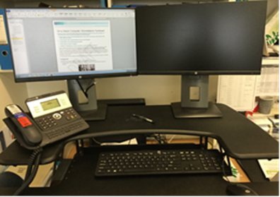  3.6 If your work involves looking at both monitors equally, are they positioned right next to each other (touching), directly in front of you and angled slightly in an arc so they are equal distances away? Use your eyes to look between screens not your neck. |  |  |  |  |  | - Reposition monitors.
3.7 If your work involves looking at one monitor for most of the time (primary monitor), is it as close to directly in front as possible?  Less important information should be at the periphery to avoid twisting the body or neck so place your second monitor to the side next to your primary monitor. |  |  |  |  |  | - Reposition monitors.
4 |  | Your keyboard and mouse  Ensure you take short breaks of approximately 30-60 seconds as needed when using a keyboard and change activities to relieve fatigue and rest tired muscles. Limit use of the mouse if it causes pain or discomfort by using keyboard shortcuts. | Yes | No | N/A | Suggested Actions/Notes
4.1 Are your keyboard and mouse level on your work surface and at elbow height?  Some desks have a keyboard tray (shelf) so it is important to ensure the mouse is on the same level as your keyboard to prevent unnecessary repetitive shoulder flexion movements. |  |  |  |  |  | - Rearrange workstation.  - Obtain larger keyboard tray if necessary.
4.2 If you rarely use the numeric keypad, is the centre of the alpha keypad in line with your midline (typically where the letter G sits)?  Sitting with the alpha keypad slightly off-centre is not uncommon and can easily be corrected. |  |  |  |  |  | - Move keyboard to correct position.  - Consider using a keyboard without a numeric keypad.
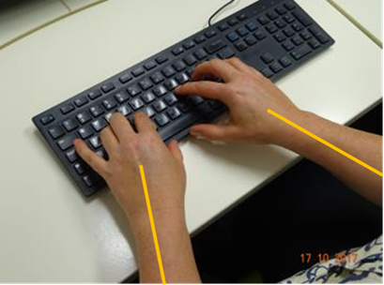  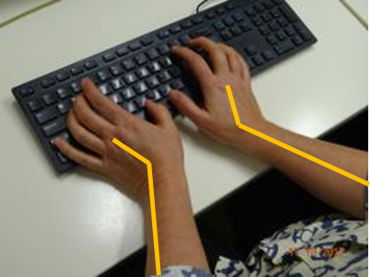  4.3 Is your keyboard flat?  Aim to keep your wrists in a neutral position and avoid bending them by keeping your keyboard flat (not propped up on its legs). |  |  |  |  |  | - Adjust keyboard.
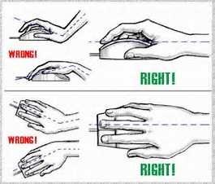  4.4 Is your mouse comfortable to use?  When using your mouse, keep your wrists straight and your upper arms relaxed. If using your mouse for long periods, consider bringing the mouse directly in front of you and pushing your keyboard back. You can always rest your dominant hand by switching to your non-dominant hand for brief periods. |  |  |  |  |  | - Move mouse.  - Remove armrests if impeding movement or if preferred.
5 | Accessories and laptops  Accessories can improve your workstation setup but it’s important to choose the most suitable option and trial items where possible. |  | Yes | No | N/A | Suggested Actions/Notes
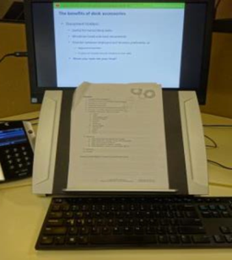  5.1 Do you often transcribe work from documents/repeatedly refer to papers whilst typing or perform reading and writing tasks?  Consider a document holder that preferably sits between the keyboard and monitor to eliminate head movement. Alternatively position one adjacent to your monitor and try using your eyes instead of moving your head to view. When performing reading or writing tasks, preferably move to a clear part of the desk in your chair to avoid twisting and use an angle board/desk slope or similar. |  |  |  |  |  | - Obtain a document holder.  - Make space on your desk for writing tasks.  - Obtain an angle board/desk slope.
5.2 Are you using a headset or speakerphone if you are writing or keying while talking on the phone?  Avoid an awkward neck posture cradling the phone between your ear and shoulder by using alternative methods such as a speakerphone or headset. |  |  |  |  |  | - Obtain a headset if using the phone and keyboard simultaneously.
Laptops
5.3 Do you use a laptop?  If you use a laptop for extended periods of time, do not use it on your lap! Use a full sized external keyboard and mouse, a docking station with full sized monitor or a laptop stand to prevent awkward postures of the neck.  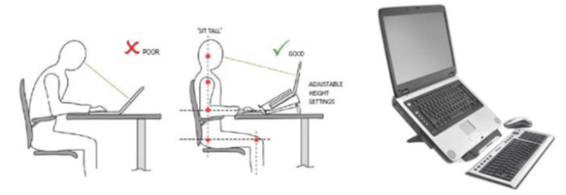 |  |  |  |  |  | - Obtain laptop accessories to enable appropriate desk set up.  - Refer to the department’s ‘Safe use of laptops’.

6 | Computer stress  As great as computers are, they can also be frustrating especially when they go slow, applications crash or do not open and you lose your work. Relieving computer stress can be just as important as sitting comfortably. | Yes | No | N/A | Suggested Actions/Notes
6.1 Does your computer slowdown, crash or experience lengthy boot-up times and interrupted connectivity more frequently than usual or seemingly more readily than those around you?  If your computer appears to be performing less effectively than usual and it is not an isolated incident, then it is important to get it checked out to prevent rising stress levels. If waiting for technical support to resolve the issue is frustrating, try working on something else in the interim.  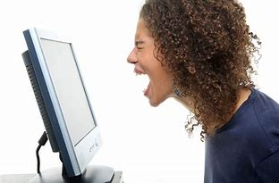 |  |  |  |  | - Raise the issue with your supervisor/manager – this may be a key factor to the effectivenss of a working from home arrangement.  - Ask for help – If using a network computer use Service Centre Online (SCO) (departmental employees only) to log a request online, find self-help articles or check for current ICT outages. For urgent issues, call 1800 680 445.  - Continue to monitor system performance in consultation with your supervisor/manager.  - Backup your files regularly.  - Be prepared – read manuals and books on computers to understand how your systems work.  - Take regular breaks from your computer. Get up and take a break every 30 minutes.  - Stand often – even for a few seconds at a time  - Have lunch and morning and afternoon tea away from your desk.  - Vary your tasks through the day so that you change your posture and use different muscles e.g. do some filing after a period of typing.  - Stretch regularly (refer to the department’s ‘Daily stretches for staff’ poster).
Sit stand workstations
6.2 How should you use your workstations?  Ensure your upper limbs are positioned appropriately and maintained when using the mouse and keyboard (elbows by sides with no reaching). Postures are to be alternated during the day with a maximum (cumulative) of four hours standing (unless medical advice states otherwise). Make sure low heeled shoes are worn. |  |  |  |  | - Follow the Safe use of sit/stand workstations fact sheet.
7 | Hazardous substances | Yes | No | N/A | Suggested Actions/Notes
7.1 Where the telecommuter is exposed to hazardous substances as part of their work tasks (e.g. toners for printers/copiers) are appropriate measures in place to ensure safe handling of hazardous substances? |  |  |  |  | - Eliminate use of hazardous substances.  - Access SDS for chemicals.  - Follow instructions regarding use/disposal.  - Risk Assessments (if required for hazardous substances).  - Use PPE as required.

8 | Access and egress | Yes | No | N/A | Suggested Actions/Notes
8.1 Are stairs, pathways and entrances free from any obstructions and trip hazards (e.g. electrical cords)? |  |  |  |  | - Remove obstructions.  - Rearrange or tape down electrical cords.
8.2 Are paths to exits sufficiently wide and free of trip hazards and obstructions to allow unimpeded passage?

8.3 Are stairs, pathways and entrances in good condition?
8.4 Are stairs, pathways and entrances well lit and easily visible?
8.5 Are stairs, pathways and entrances provided with handrails where required?
9 | Electrical | Yes | No | N/A | Suggested Actions / Notes
9.1 Is electrical equipment free from obvious damage? |  |  |  |  | - Frayed cords, damaged power boards or other faulty electrical equipment is to be removed from use.
9.2 Are there a sufficient number of power points to avoid overloading? |  |  |  |  | - Power boards are to be used not double adaptors.
9.3 Is electrical equipment protected from damage? Is a safety switch installed at the location and is it tested regularly? |  |  |  |  | - What strategies are in place for electrical safety?
10 | Fire Safety | Yes | No | N/A | Suggested Actions/Notes
10.1 Are smoke alarms installed and maintained? |  |  |  |  | - Install smoke alarm.  - Check annually.
11 | Emergency preparedness | Yes | No | N/A | Suggested Actions / Notes
11.1 In the event of an emergency has the employee developed a plan for:  - Evacuation e.g. a fire in the home.  - Medical emergency. |  |  |  |  | - Develop an emergency evacuation strategy – consider whether small fires will be addressed (e.g. need for a relevant fire extinguisher or blanket) or evacuation will occur.  - In the event of a medical emergency for the employee who will be contacted and how this will be achieved?
12 | Noise | Yes | No | N/A | Suggested Actions / Notes
12.1 Is the noise in the immediate area low enough not to be disruptive or distracting? |  |  |  |  | - Eliminate/Reduce noise to an acceptable level.
13 | Air circulation | Yes | No | N/A | Suggested Actions / Notes
13.1 Is the air circulation, temperature and humidity at a comfortable level? |  |  |  |  | - Ensure adequate circulation and means to regulate temperature.

Acknowledgement

If you have identified any other hazards in your proposed workspace, please provide further details below so these can be reviewed.

Person completing assessment

- If a self assessment is completed, an independent assessment may be completed at a later time to demonstrate departmental risk management processes. This will be arranged at a mutually convenient time for the employee and employer.
- The employee undertaking the working from home arrangement consents to this independent assessment and understands that if consent for this independent assessment is withdrawn then the flexible work arrangement agreement will cease at this time.

Name: |  | Position:
Signature: |  | Date:

For completion by the Manager/Principal/Supervisor

- Hazards and risks relevant to this checklist process have been identified Yes No
- Risks have been managed to an acceptable level (e.g. residual risk is low?) Yes No
- Items that require controls (short-term) are recorded below Yes No
- Any hazards or risks that require ongoing monitoring are recorded on the Employee/Manager Agreement Yes No

Control plan

This plan is for issues that can be remedied in the next 4 weeks. Completion of these tasks will enable progression of the work from home arrangement.

Issue and recommended control (what needs to be done) | Date to be implemented | Whose responsibility | Planned review date | Completed signature of employee | Completed signature  of supervisor

Name: |  | Position:
Signature: |  | Date:
Comments:

