Regional
Emergency Response Plan

2015 - 2016

A current hardcopy of this plan should be kept on file and be accessible in the event of a disaster or emergency.

Emergency Response Plan key contact
Key Contact: | [Name]
Phone Details: | [Phone]
Email Details: | [email]
Main Office: | [Regional Office location]
Document Status: | [Draft /final]

Details
DET Region
Regional Office/s | [Location/s and address/es]
Electoral areas

Approvals
Name | Title | Signature | Date
[Name] | Regional Director
[Name] | Executive Director – State Schools, Operations

Review
Next review date

Contents
1. Purpose 4
2. Scope 4
3. Response Strategies 4
4. Mission 5
5. Execution 5
Imminent event 6
Sudden impact 6
Regional Office(s) 7
6. Administration and Logistics 7
7. Command and Communications 8
8. The Regional Response Team (RRT) 11
9. Regional Office/s Map/s 12
10. Evacuation Response 13
11. Lockdown Response 14
12. Temporary Closure Response 15
13. Specific emergencies – response procedures 16
14. The DET Response Structure 20
15. Executive Response Team Contacts 21
16. Regional communications details 22
17. External Emergency numbers 23
DET Contacts (When ERT not enacted) 24
Local Community Contacts 24
Disaster Management Groups 24
18. Staff with special needs 26
19. Staff trained in First Aid 27
20. Regional State School principal contacts 28
21. Building information summary 29
22. Suitability assessment to re-open the school or campus. 30

Purpose
The purpose of this Emergency Response Plan (ERP) is to provide details of how <insert region name> will prepare for and respond to a disaster or emergency situations.

Scope
This Emergency Response Plan applies to all staff, visitors and contractors at <insert region name> Offices.

Response Strategies
When this Region is impacted, or is about to be impacted, by a disaster or emergency event, this plan will be enacted at the direction of the Regional Director who will assume the role of Regional Response Controller.
Each disaster or emergency may have extenuating circumstances which require the application of an additional appreciation to provide a solution to new risk or circumstance. The department has adopted an ‘all hazards approach’ to the planning of response strategies to disasters or emergencies and subsequently there are generally three response strategies that can be implemented prior to, or during a disaster or emergency.
The response strategies, which can be implemented singularly or jointly, are:
- Evacuation of the facility;
- Lockdown of the facility;
- Temporary Closure of the Facility (Schools)
It is also noted that disasters or emergencies may also be categorised as:
- ‘rising tide’ or ‘slow burn’ events which enables decision makers to act prior to the impact of the event; or
- sudden or spontaneous events for which there are no warnings or indications that allow pre-emptive actions and the vent has to be responded to during or post impact.
Disasters or emergencies may occur under such circumstances that the Regional Response Controller can make pre-emptive decisions to take action and best prepare the staff to provide support to schools for the event. This is the preferred scenario for the Department.
In this Region there are Regional, Corporate Service offices and schools across the Region. Each school is responsible for uploading a current Emergency Response Plan into the department’s nominated central storage repository. The Regional Response Team can then access the relevant school Emergency Response Plan from the central storage repository as required.
Regional buildings should have separate Building Emergency Procedures and staff should be familiar with these plans. Each site’s emergency procedures advise staff what to do in the event of Fire/smoke, Medical Emergency, Bomb Threat, Internal Emergency, Personal Threat, External Emergency, and Evacuation. (Identify where Plans stored)
Some incidents may occur quickly however their impact may not be neither serious nor long term. Guidance on such responses to incidents, accidents, or individual injuries is available on the Department’s One Portal via the ESMU site.
This plan is enacted when the disaster or emergency escalates beyond being managed under those mentioned plans and requires additional levels of local and regional or executive support.
This plan connects to the Regional Business Continuity Plan as required.

Mission
To ensure the safety of students, staff and any other persons within the region.
To coordinate the regional response to a disaster or emergency.
To minimise the damage to DET property and facilities.
To resume educational services when safe to do so.

Execution
In the lead up to or the impact of a significant event, the Regional Response Controller (RRC) will decide whether to stand up the Regional Response Team and Regional Coordination Centre (RCC). The Regional Response Team is listed in Section 8 and will be scalable as determined by the RRC.

Imminent event
Upon identifying an emerging significant risk from a ‘rising tide’ event to, or within, the Region, the RRC should:
- Form the Regional Response Team (RRT);
- Analyse the risk and expected impact on the Region;
- Engage with the District Disaster Coordination Centre (DDCC) – as established;
- Consider the courses of action;
- Consult with the relevant School Response Controllers (Principals)
- Decide on the regional strategy and implement the strategy;
- Request resources if necessary e.g. Deployable Response Team (DRT)
- Manage the School Closure system for the region;
- Commence the Communication Strategy;
- If formed, brief the Executive Response Team (ERT) on the progress and status otherwise advise the Emergency and Security Management Unit (ESMU) and the supervising ADG State School - Operations; and
- Engage the Business Continuity Plan.

Sudden impact
Upon the impact of a sudden event on the Region, the Regional Response Controller (RRC) should;
- Review the actions of the impacted SRCs;
- Overview the assessment of the safety of all students and staff in the region;
- Activate the RRT and Regional Coordination Centre (RCC);
- Commence the Communication Strategy; Ensure the lodgement and approval of a Critical Incident Alert Notification and e-mail Alert Notification to CEP Media.ccm@dete.qld.gov.au and School Operations School.Alert@dete.qld.gov.au.
- Monitor the responses under the School Emergency Response Plans
- Manage the School Closure system for the region;
- Engage with the District Disaster Coordination Centre if established;
- If formed, regularly brief the Executive Response Controller, otherwise advise the Emergency and Security Management Unit (ESMU) and the supervising ADG State School - Operations;
- Monitor the School Response Controllers from a welfare perspective
- Engage the Business Continuity Plan.
- Coordinate with Regional BAS Office to prioritise repairs to schools.
- Consult with SRC’s on resuming business and educational support services; Monitor NCR site requirements, maintain and facilitate any ongoing support, outside agency involvement and address any community issues at regular junctures following the regional emergency.
- Ensure the management of the RRT and RCC through systems, briefings and communications to ensure shared situational awareness.

Regional Office(s)
If the event, either rising tide or sudden, has also impacted on the Regional Office location then in addition to the above:
- Assess safety of regional staff
- Assess the status of the Regional Office/s, noting BAS protocols;
- If any visible damage or potential hazards on the site, e.g. asbestos, engage BAS for site inspection;
- If required consider closing the office and seeking an alternate operating location;
- If formed, regularly brief the Executive Response Controller, otherwise advise the Emergency and Security Management Unit (ESMU) and the supervising ADG State School - Operations;
- Utilise Communication Strategy;
- Monitor the Regional staff from a welfare perspective
- Implement the Regional Business Continuity Plan as required.
- If closure was necessary, re-open the Regional Office/s after conducting a Suitability Assessment and determining that it is safe to do so.

Administration and Logistics
Hard copies of the Regional Emergency Response Plan and the Business Continuity Plan should be stored in the main Administration Office of the Regional offices and in any pre-determined location for the Regional Coordination Centre (RCC), and be held by the Regional Response Team (RRT).
The Regional Coordination Centre which is a nominated location for the RRC and RRT to operate from should be always ready and have the capability to establish communications with schools, principals, other, stakeholders, the Executive Coordination Centre, the District Disaster Coordination Centre and the Regional Response Team if required.
All documentation generated or received at the RCC is to be stored in hardcopy or electronic for later reference. In the event of death, serious bodily injury or possible litigation issues, liaise with the Manager, Legal and Administrative Law Branch.
In the event of death or serious bodily injury, ensure the Director, Workplace Health and Safety QLD has been notified as soon as possible by the quickest means of communication available, as well as on the prescribed form within twenty-four hours, utilising MyHR WH&S Solutions reporting mechanism via One Portal).
At the conclusion of the response to an event the RRC will conduct a Regional Debrief.

Command and Communications
The Regional Director will assume the role of the Regional Response Controller (RRC) and will form, and chair, the Regional Response Team (RRT). The RRC is responsible to the Executive Response Controller (ERC). (See Section 14)
The RRC can make decisions about the Temporary Closure and Re-opening of schools in accordance with the CE Directive 1/2015.
When formed, the RRT is to establish and maintain communications with the Executive Response Team (ERT) as practicable. In the absence of communications the RRC must operate independently until communications are able to be established.
A senior officer represents the Region on the DDCG and may have support staff assisting. This may be the RRC or it may be another delegated member.
The basic structure of the RRT and their broad responsibilities are represented below and this structure may be adjusted according to the nature and complexity of the event.
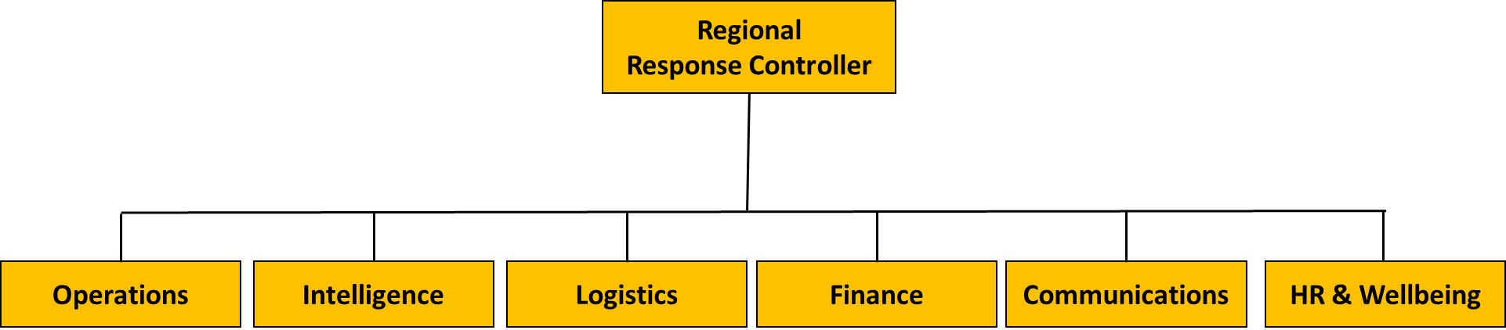

Role | Responsibilities
Regional Response Controller | Overall lead and coordinator of the disaster or emergency response and recovery in the Region.
Operations | Responsible for providing support to RRC and RCC including collecting and processing information about the incident and response operations (situational awareness). Also responsible for managing and tasking additional resources to support operations and maintaining liaison with external agencies and DDCC.  Responsible for overall management of the RCC and preparation of a Strategic Assessment if required and any Response Plans.
Intelligence | To collect, analyse and display information and intelligence to support situational awareness and to prepare briefs and internal sitreps as required.
Logistics | Responsible for securing materials, resources, services and additional staff to sustain operations and restore educational services (Business Continuity).
Finance | Supports the other functional areas through the financing of operations as well providing administrative support and management of the Coordination Centre. Responsible for tracking of response costs for corporate accounting.
Communication | Information and communications management internally and externally– see the Disaster and Emergency Communications Strategy.
HR and Wellbeing  (Support) | Conduct activities to support staff resilience. Monitoring the management of risk and the welfare of all staff through the advice on entitlements, welfare and wellbeing support.

The RRC may also manage the liaison with the relevant Local Disaster Management Group/s (LDMG/s). In some areas this may be delegated to a School Response Controller depending on the location of the School. A list of key contacts is included in this ERP. It lists the school and regional response entities and mechanisms to assist communications before, during or after an event. It also lists other agency and stakeholder contact points.
The RCC must establish communications methods including redundancies such as phone, mobile phones, satellite phones, internet, SMS Global and email. The Department has a mobile communication platform that can be requested to be relocated to the region.

The Regional Response Team (RRT)
Role | Assigned staff including shadow | Contact details
Response Controller | Primary contact
 | Back-up contact
Operations | Primary contact
 | Back-up contact
Intelligence | Primary contact
 | Back-up contact
Logistics | Primary contact
 | Back-up contact
Finance | Primary contact
 | Back-up contact
Communication | Primary contact
 | Back-up contact
HR and Wellbeing  (Support) | Primary contact
 | Back-up contact

DDMGs
LDMGs
A copy of this table should be provided to all schools within the Region for inclusion within each school’s Emergency Response Plan.

Regional Office/s Map/s
<Insert Area map here.>

Distance to Primary off-site assembly point:
A
prox. time to reach Primary off-site assembly point:
Distance to Secondary off-site assembly point:
Approx. time to reach Secondary off-site assembly point:
Legend
Primary off-site assembly point
Route to Primary off-site assembly point

Secondary off-site assembly point

Route to Secondary off-site assembly point

Emergency services access point

Evacuation Response
The fields below contain example responses for guidance and should be edited to suit the location.
Priority | Safety of staff, members of the community and/or site visitors.
Reporting the emergency | - Contact Emergency Services immediately on 000  - Notify the ADG or ERC pending arrangements enacted.
Evacuation  Edit to suit the location | Signal
 | Procedure
 | Special considerations
 | Special responsibilities
Evacuation assembly  Edit to suit the location, replacing the example with the process in black font. | Assembly area/s
Assembly procedure
1. Personnel lists are checked.
2. Report all persons unaccounted for to the RRC.

Evacuation clearance  Edit to suit the location | 1. No person is to return to any area of the Regional Office until advised by the RRC.  2. The clearance signal is……
General principles  Edit to suit the location, replacing the example with the process in black font. | Evacuation procedures will be displayed on Emergency Evacuation maps in all rooms.  - FIRST PRIORITY is to the safety of all persons in the office.  - ALL staff and visitors are automatically involved.  - ALL VISITORS should sign the Visitors book at the office.  - NO person should be placed in a position of risk.  - Regional Response Controller is responsible for ensuring the electricity is turned off and that Emergency Services are contacted and given all assistance required.
Communications  Edit to suit the location | - If the evacuation goes for an extended time then the Regional Response Controller informs the Emergency and Security Management Unit on 3034 6012.
Pre-arrangements  Edit to suit the location, replacing the example with the process in black font. | - Site Emergency Evacuation Maps must be clearly displayed in all rooms.  - Visitor sign-in registers maintained in the office.  - Emergency personnel lists kept by exit door.  - Evacuation exercises conducted twice a year and records kept in MyHR WH&S.

Lockdown Response
The fields below contain example responses for guidance and should be edited to suit the location.
Priority | This procedure minimises access to the Regional Office and secures all persons in offices.
Reporting the emergency | - Contact Emergency Services immediately on 000  - Notify the EMSU on 3034 6012 or ERC pending arrangements enacted.
Lockdown  Edit to suit the location, replacing the example with the process in black font. | Signal
Procedure
- Regional Office doors are locked by office personnel.
- Access to any and all persons denied.
- Staff not in their own offices will remain in the room they are currently in until told it is safe to move.
- Personnel lists are checked.
- Report all unaccounted for to the Regional Response Controller
- Staff and visitors remain in their offices until told that the building is safe.
 | Special considerations
 | Special responsibilities
Lockdown cancellation  Edit to suit the location | 1. Staff and visitors remain in offices until advised by the Regional Response Controller that the Lockdown procedure is cancelled.  2. The clearance signal is …..
General principles  Edit to suit the location, replacing the example with the process in black font. | - A lockdown prevents persons from entering the Regional Office.  - Normal routine should re-commence as soon as possible after the event.  - Staff to be vigilant in reporting the entry of unauthorised person or persons into the building.
Communications  Edit to suit the location | - If the lockdown goes for an extended time then the Response Controller informs the Emergency and Security Management Unit on 3034 6012.
Pre-arrangements  Edit to suit the location, replacing the example with the process in black font. | - Facilities can be locked internally.  - Visitor sign-in registers maintained in the office.  - Emergency personnel lists kept.  - Staff and students will be made aware of this signal and its meaning through lockdown exercises conducted twice a year and records kept in MyHR WH&S.

Temporary Closure Response
The fields below contain example responses for guidance and should be edited to suit the location.
Priority | Safety of staff, members of the community and/or site visitors.  Staff must remain off-site until advised by the Regional Response Controller that the Building is safe and available to be re-occupied and re-opened.
Decision | The RRC has the authority to close the Regional Office as considered necessary
Reporting the closure  Edit to suit the location, replacing the example with the process in black font. | - Notify the Executive Response Controller or the Emergency and Security Management Unit on 3034 6012.  - Notify the local Radio Station  - Notify staff – phone tree  - Notify school community – School Closures website, messaging  - Notify other stakeholders
Temporary Closure  Edit to suit the location, replacing the example with the process in black font. | Prepare  - Engage the Regional Response Team  - Prepare for the closure with stakeholders if practicable  - Undertake required communications
Respond
- Monitor the event and stay informed.
- Maintain communications with the Executive Response Team, DDMG and LDMG.
- Wait till safe to liaise with BAS to conduct site for inspection.
- Monitor damage reports. Meet daily with BAS to review priorities and assign resources.
- Assess staff status and support required
- Engage Business Continuity Plan as required
- Undertake Suitability Assessment for decision to re-open or not.
Recover
- Liaise with BAS re repair schedule
- Manage and support staff welfare issues
- Monitor business continuity activities
 | Special considerations
Re-opening  Edit to suit the location, replacing the example with the process in black font. | - Notify the Executive Response Controller or ESMU depending arrangements enacted  - Notify Radio Station  - Advise LDMG & DDMG if stood up.
General principles | - ‘Safety before schedule’ Normal routine should re-commence as soon as possible after the event and when safe to do so.
Communications

Specific emergencies – response procedures
The fields below contain example responses for guidance and should be edited to suit the location.
Building Fire  Edit to suit the location, replacing the example with the process in black font. | <As appropriate insert any additional mitigation steps relevant to your facility that you have identified in your risk assessment>  - Call 000 for emergency services and follow advice.  - Activate the fire alarm.  - Report the emergency immediately to the Regional Response Controller who will convene your Regional Response Team if necessary.  - Extinguish the fire (only if safe to do so).  - If appropriate, follow the procedure for on-site evacuation.  - Evacuate to the <Insert the location of your assembly point/s>, closing all doors and windows.  - Check that all staff and visitors are accounted for.  - Contact the Emergency and Security Management Unit on 3034 6012.
Bushfire  Edit to suit the location, replacing the example with the process in black font. | <As appropriate insert any additional mitigation steps relevant to your facility that you have identified in your risk assessment>  - Call 000 for emergency services and follow advice.  - Report the emergency immediately to the Regional Response Controller who will convene your Regional Response Team if necessary.  - Determine appropriate response strategy (evacuate or lockdown) in consultation with emergency services, if possible.  - If evacuation is required and time permits before you leave:  - Make sure you close all doors and windows  - Turn off power and gas.  - Check that all staff and visitors and contractors are accounted for.  - Listen to TV or local radio on battery-powered sets for bushfire/weather warnings and advice.  - Contact the Emergency and Security Management Unit on 3034 6012.
Major external emissions/spill (includes gas leaks)  Edit to suit the location, replacing the example with the process in black font. | <As appropriate insert any additional mitigation steps relevant to your facility that you have identified in your risk assessment>  - Call 000 for emergency services and follow advice.  - Report the emergency immediately to the Regional Response Controller who will convene your Regional Response Team if necessary.  - Turn off gas supply.  - If the gas leak is onsite, notify your gas provider.  - If appropriate, follow the procedure for on-site evacuation.  - Alternatively this may need to be to an off-site location.  - Check staff and visitors are accounted for.  - Await ‘all clear’ advice from emergency services or further advice before resuming normal activities.  - Contact the Emergency and Security Management Unit on 3034 6012.
Intruder  Edit to suit the location, replacing the example with the process in black font. | <As appropriate insert any additional mitigation steps relevant to your facility that you have identified in your risk assessment>  - Call 000 for emergency services and seek and follow advice.  - Report the emergency immediately to the Regional Response Controller.  - Do not do or say anything to the person to encourage irrational behaviour.  - Initiate action to restrict entry to the building if possible and confine or isolate the threat from building occupants.  - Determine whether evacuation or lock-down is required. Do this in consultation with the Police where possible.  - Evacuation only should be considered if safe to do so.  - Contact the Emergency and Security Management Unit on 3034 6012.
Bomb or substance threat  Edit to suit the location, replacing the example with the process in black font. | <As appropriate insert any additional mitigation steps relevant to your facility that you have identified in your risk assessment>  - Call 000 for emergency services and seek and follow advice.  - Report the threat to the Regional Response Controller.  - Do not touch any suspicious objects found.  - If a suspicious object is found or if the threat specifically identified a given area, then evacuation may be considered:  - If appropriate under the circumstances, clear the area immediately within the vicinity of the object of staff.  - Ensure staff are not directed past the object  - Ensure staff that have been evacuated are moved to a safe, designated location  - Contact the Emergency and Security Management Unit on 3034 6012.  If a bomb/substance threat is received by telephone:  - Do not hang up.  - If possible fill out the bomb threat checklist while you are on the phone to the caller.  - Keep the person talking for as long as possible and obtain as much information as possible.  - Have a co-worker call 000 for emergency services on a separate phone without alerting the caller and notify the Regional Response Controller.  If a bomb/substance threat is received by mail:  - Place the letter in a clear bag or sleeve.  - Avoid any further handling of the letter or envelope or object.  - Call 000 for emergency services and seek and follow advice.  - Notify the Regional Response Controller.  If a bomb/substance threat is received electronically:  - Do not delete the message  - Call 000 for emergency services and seek and follow advice  - Notify the Regional Response Controller.  - Contact the Emergency and Security Management Unit on 3034 6012.
Internal emission or spill  Edit to suit the location, replacing the example with the process in black font. | <As appropriate insert any additional mitigation steps relevant to your facility that you have identified in your risk assessment>  - Call 000 for emergency services and seek and follow advice.  - Report the emergency immediately to the School Response Controller who will convene your SRT if necessary.  - Move staff and students away from the spill to a safe area and isolate the affected area.  - Seek advice in regards to clean up requirements, and if safe to do so, the spill can be cleaned up by staff. Personal Protective Equipment should be worn as per the requirements of the Material Safety Data Sheet and Safety Work Procedure.  - Contact the Emergency and Security Management Unit on 3034 6012.
Severe Weather event  Edit to suit the location, replacing the example with the process in black font. | <As appropriate insert any additional mitigation steps relevant to your facility that you have identified in your risk assessment>  Sudden event during operational hours:  - Call 000 if emergency services are needed and follow advice.  - Report the emergency immediately to the Regional Response Controller who will convene your Regional Response Team if necessary.  - Before the storm, store or secure loose items external to the building, such as outdoor furniture and rubbish bins.  - Disconnect electrical equipment – cover and/or move this equipment away from windows.  - Secure windows (close curtains & blinds) and external doors. If necessary, tape windows and glass entrances. Utilise boards and sandbags if required.  - Instigate a lockdown.  During the severe storm:  - Remain in the building and keep away from windows  - Restrict the use of telephone landlines to emergency calls only, particularly during a thunderstorm.  - Report any matter concerning the safety and wellbeing of students, staff and visitors to the School Response Controller.  - Listen to local radio or TV on battery-powered sets for weather warnings and advice.  Forecast imminent event (e.g. cyclone, floods)  - If weather warnings and advice from the State Disaster Management Group indicate that the location will be impacted by a severe weather event, the Regional Response Controller will follow the decision-making process to determine if the school will be temporarily closed.  - The Regional Response Team will be convened.  - If the Regional Office is to be temporarily closed, then all stakeholders will be advised.  - The Temporary Closure procedure needs to be implemented.  - After the event, if the school is situated in the impact zone, then Building and Asset Services (BAS) will determine if the site is safe for the Regional Response Controller to enter to undertake a Suitability Assessment to Re-open.  - The Regional Response Team may need to operate from an alternative Regional Coordination Centre location.
Earthquake  Edit to suit the location, replacing the example with the process in black font. | <As appropriate insert any additional mitigation steps relevant to your facility that you have identified in your risk assessment>  - Call 000 for emergency services and seek and follow advice.  - Report the emergency immediately to the Regional Response Controller who will convene your Regional Response Team if necessary.  - Evacuate to assembly area/s.  - Check that all staff and visitors are accounted for.  - Await ‘all clear’ advice from emergency services or further advice before resuming normal activities.  - Contact the Emergency and Security Management Unit on 3034 6012.

The DET Response Structure

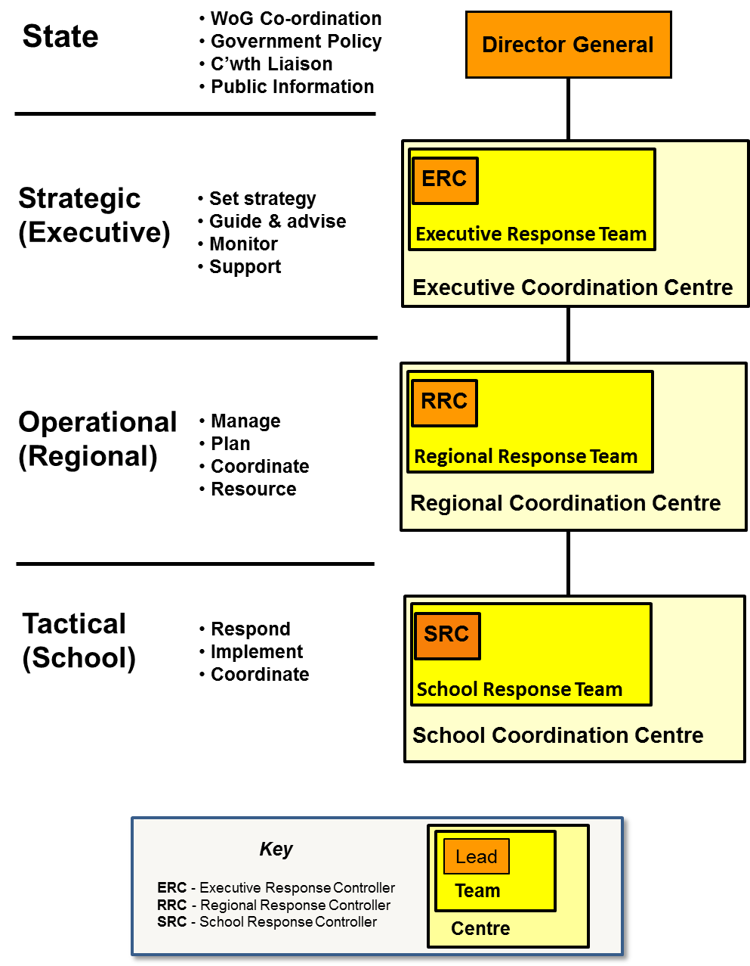
15. Executive Response Team Contacts
This table will be provided by the Emergency and Security Management Unit.
Role | Assigned staff including shadow | Contact details  (Phone & email)
Executive  Response Controller | Primary
 | Back-up
Operations Officer | Primary
 | Back-up
Intelligence Officer | Primary
 | Back-up
Logistics Officer | Primary
 | Back-up
HR and Wellbeing Officer | Primary
 | Back-up
Advisory Group

Regional communications details

Phone tree
In a disaster or emergency event, the following phone tree will be activated. (Example only, please adjust the tree for the location.)

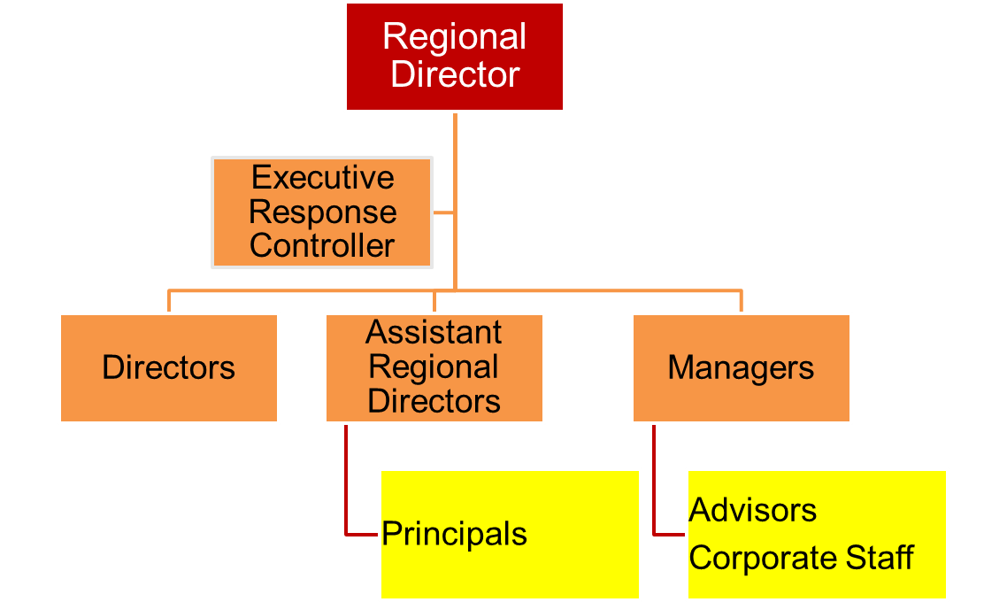

External Emergency numbers
Display a copy of this list next to your administration phone/s.
Group | Contact/details | Phone number
Police | Life-threatening or time critical emergency | 000 – calling from land line
 | Non-life threatening incident | 131 444
 | Local Police Station
Ambulance |  | 000
LDMG
DDMG
Qld Fire and Emergency Services (QFES) |  | 000
State Emergency Service (SES) |  | 132 500
Hospital/s
Electricity | Local number
Water Corporation | Local number
Gas supplier
Building and Asset Services | Regional Manager
Department of Community Safety (Regional Office)
Child Safety Services | http://www.childsafety.qld.gov.au/contacts/index.html | 1800 811 810 (Qld only)
Dept of Natural Resources & Mines | https://www.dnrm.qld.gov.au/our-department/contact-us | 13 QGOV (13 74 68)

DET Contacts (When ERT not enacted)
Key contact | Contact/details | Phone number
Assistant Regional Director
Assistant Regional Director
Assistant Regional Director
Infrastructure Manager
Senior Health & Safety Consultant
DET Emergency & Security Management Unit (ESMU) | qld-dete-emru@id.ngcomms.net | 07 3034 6012

Local Community Contacts
 | Contact/details | Phone number
Transport Operator

Disaster Management Groups
 | Contact/details | Phone number

Other Institutions
 | Contact/details | Phone number
ECEC
Independent Schools
Catholic Schools

Staff requiring assistance to evacuate
* Response – evacuation, lockdown or temporary closure
Name | Room | Condition | Response*/ Assistance required | Person responsible | Family/Carer contact & mobile

Staff trained in First Aid
Staff Member | Training | Date Qualified To

Regional State School principal contacts
School | Name | Email | Phone No.  (Day) | Phone No.  (After Hours)

Building information summary
Telephones (Landlines):
Location |  | Number |  | Location |  | Number
Alarms | Location |  | Monitoring Company |  | Location of Shut-off Instructions
Fire:
Intrusion:
Other:
Utilities | Location |  | Service Provider |  | Location of Shut-off Instructions
Gas / Propane:
Water:
Electricity:
Sprinkler System
Location of Control Valve:
Location of Shut-off Instructions:
Boiler Room
Location:
Access:
Emergency Power System
Type:
Location:
Provides Power To:
Location of Shut-off Instructions:

Building and Site Hazards
Hazard Description | Location

Suitability assessment to re-open the school or campus.
After an event which has caused the school to temporarily be closed the following process needs to occur in the course of deciding to re-open the school. Principals need to undertake an assessment to determine to the impact of the event on essential infrastructure and resources.
The following flowchart and assessment have been provided to Regions to assist with advice provided to Principals following an event.

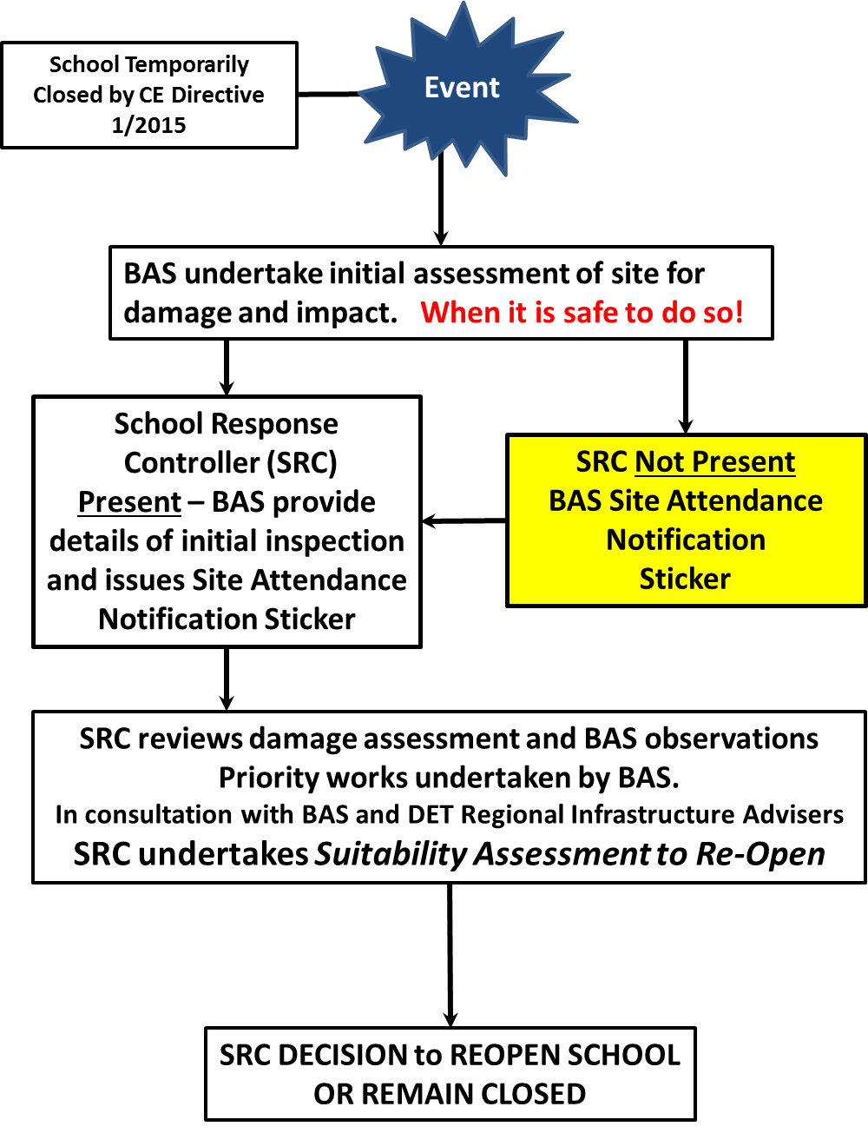

SUITABILITY ASSESSMENT
Item | Considerations |  | Observation/Mitigation
ACCESS
Is there a Police or District Disaster Management Group direction to close the school? | Yes | If the direction has not been revoked then the school or campus must remain closed.
 | No
Does storm debris prevent safe access around the school? | Yes | Is there a large amount of debris in school or campus grounds that prevents safe movement/supervision around the site?  Can affected areas be barricaded and traffic diverted to allow safe movement around the school or campus?
 | No
Are access roads to the school cut by debris or flood waters? | Yes | Liaise with the Local Disaster Management Group (LDMG) to determine when the roads will be safe to travel.  Ensure access roads are not at risk of being cut off due to rising flood waters that will inhibit staff and students to leave the site safely.  Contact the Local Disaster Management Group or the Police.
 | No | If the site can be accessed safely then consider re-opening if there are sufficient resources to provide for the safe supervision of students.
BUILDINGS
Have buildings been damaged? | Yes | If all buildings are damaged then then school or campus remains temporarily closed.  If not all buildings are damaged then consider the following:  - Can access to damaged buildings be restricted to allow safe unimpeded access to other areas of the school or campus?  - Are there sufficient teaching spaces available to deliver services (even in a limited capacity)?  - Have Building & Asset Services (BAS) inspected the buildings and provided certification that the buildings are safe to reoccupy?
 | No
HAZARDS
Has asbestos-containing material (ACM) been exposed/damaged in the school grounds? | Yes | DET Policy is that no persons can be in the vicinity of damaged ACM or on site when ACM removal is undertaken.  If ACM requires specialist removal then the school or campus needs to stay closed. Contact Building & Asset Services (BAS).
 | No
WATER
Has water supply to school been disrupted? | Yes | If Yes, can bottled water be sourced quickly for staff/student use? Parents can be asked to provide water for students but some bottled water will be required for emergencies. If Yes, is water available for amenities such as toilets? Contact the Infrastructure Manager.
 | No
TOILETS
Have septic tanks been affected? | Yes | Have all the grounds been affected by sewage overflow or just an area?  Can this area be barricaded off to restrict access without impacting on teaching space?
 | No
Are the toilet buildings safe to be used? | Yes | Are they structurally safe and accessible?
 | No | Are other facilities available nearby or can Porta-loos be sourced.
COMMUNICATIONS
Have external telecommunications been affected? | Yes | If landlines have been affected then is there mobile phone capacity? Are mobile phones readily accessible? Are satellite phones required? Does an adjoining site have phones?
 | No
ELECTRICITY
Has the electricity supply been affected? | Yes | Are there power lines down within the school? Contact Energex immediately on 13 19 62. School must remain closed.  Does the school have an external generator supply point installed?  Can the supervision of students be undertaken without power to the classrooms? Is power required to operate the septic tanks?
 | No
STAFFING
Has the event impacted on staff availability to support an acceptable staff/student supervision ratio? | Yes | If there is limited capacity to supervise students safely then remain closed.  Consider contacting the Regional Response Team to request staff wellbeing support.
 | No
OTHER ISSUES

DECISION RECORD
Record the decision to keep the school Temporarily Closed or to Re-open the school.
Signature: Date : Time:

