Guidelines for the administration of medications in schools
To be read in conjunction with the Administration of medications in schools procedure.
This document provides best practice advice for schools, with consideration for students’ individual needs and the local context.

Contents
1. Types of medications 4
1.1 Routine medication 4
1.2 ‘As-needed’ medication 4
As a non-emergency response 5
As an emergency response 5
Determining staff capability 5
When administering emergency medication requires medically trained staff 6
1.3 Emergency first aid medications 6
Adrenaline auto-injectors (general use for first aid kit) 6
Asthma reliever/puffer (general use for first aid kit) 6
1.4 Over-the-counter (OTC) medications 7
2. Medication side effects and errors 8
2.1 Side effects 8
2.2 Medication errors 8
2.3 Responding to and recording medication side effects, errors and incidents 8
3. Managing the administration of medications in schools 9
3.1 Communicating with parents/carers 9
3.2 Documentation requirements 9
Provide the correct forms to parent/carer/student 9
Check forms received from parent/carer/student 9
Prepare and attach appropriate record form and other relevant information 9
Provide information to principal/delegate for consideration 11
3.3 Medical authorisation 12
Checking the pharmacy label 13
Written medication authorisation 13
If medical authorisation cannot be confirmed 13
4. Receipt and transport of medications 14
4.1 Temperature control 14
4.2 Original container and intact packaging 14
5. Administration of medications 15
5.1 Staff administration 15
5.2 Student self-administration 15
Controlled drugs 15
Routine medications 15
Asthma medication 16
Adrenaline auto-injectors 17
Emergency medications (other than for asthma or anaphylaxis) 17
Supervision of students who self-administer their own medication as an emergency response 17
5.3 Insulin administration 17
6. Storage 19
6.1 Dose administration aids (DAA) 19
6.2 Pill-cutters 19
7. Disposal 20
8. Camps and excursions 21
9. State school operated residential boarding facilities 22
10. Specific advice regarding medicinal cannabis 22
11. Specific advice about chemical restraint 22
Appendix 1: Considerations for storage of medications 23
Appendix 2: 7 RIGHTS of safe medication administration in schools 24
Appendix 3: Approval requirements for self-administration 27
Appendix 4: Risk assessment for determining self-administration 28
Appendix 5: Responding to medication side effects, errors and incidents 29
Appendix 6: Recording actions following medication side effects,
errors and incidents 30

Types of medications
Students may require medication to manage ongoing health disorders or conditions, short-term illnesses or in a medical emergency.
For the purposes of the Administration of medication in schools procedure, medications can be described as ‘routine’, ‘as-needed’, or ‘emergency first aid’.
All medications, including those purchased over the counter (OTC) without a prescription (e.g. paracetamol or alternative medicines) are drugs or poisons and may cause side effects or adverse reactions. As such, state schools are required to have medical authorisation from a prescribing health practitioner to administer most medication to students. In Queensland state schools, the only medication that doesn’t require this authorisation is the emergency first aid medication kept in the first aid kit/s as the Medicines and Poisons (Medicines) Regulation 2021 (Qld) authorises schools to purchase and administration these medications.
See Table 1: Types of medications for an overview of the medications which may be administered at school.

Routine medication
Medication that is prescribed to be taken regularly over a period of time, can be referred to as ‘routine’.
Depending on the period of time they are required to be administered, routine medications, can be considered ‘short-term’ or ‘long-term’. ‘Short-term’ could be a period of a few days through to a few weeks. ‘Long-term’ could be a few months to a few years.

‘As-needed’ medication
Prescribing health practitioners (e.g. doctor, dentist, optometrist, nurse practitioner) may prescribe medication to students that is to be administered ‘as needed’ or ‘as required’ in response to certain symptoms.
A pharmacy label on the student’s prescribed medication indicating it is to be given ‘as needed’ does not provide sufficient information for school staff to safely administer it, as they are not qualified to make clinical decisions about when medication is required.
For school staff to safely administer ‘as-needed’ medication, the school requires detailed written advice (i.e. a medication order) from the prescribing health practitioner regarding:
- the specific signs and symptoms that the student would show indicating the medication needs to be administered;
- the maximum number of dosages allowed during the school day and over a 24-hour period;
- the minimum length of time allowed between dosages; and
- the expected response the student would have after taking this medication so that atypical symptoms or side effects that could require medical attention are easily identified.

As a non-emergency response
If the school is considering administering ‘as-needed’ medication to a student as a non-emergency response, they will need to know when the medication was most recently given to the student. This will influence when it is able to be administered at school. If this is not known by school staff, parents/carers need to be contacted. Likewise, schools need to advise the parent/carer when they have administered the medication to the student.

As an emergency response
Some students with health support needs may require medication to be administered as an emergency response.
These students should have either an Action Plan (if they have anaphylaxis or asthma) or an Emergency Health Plan (if they have another health condition e.g. diabetes, epilepsy).
The administration of some medications (e.g. Midazolam for the emergency treatment of a seizure, or glucagon for severe diabetic hypoglycaemia) requires specialist training beyond that provided as part of first aid training.
Principals/delegates need to ensure appropriate staff are trained in the administration of these medications.
Refer to the Managing students’ health support needs at school and Supporting students with asthma and/or at risk of anaphylaxis at school procedures for further requirements.

Determining staff capability
The administration of specialised emergency medication varies in complexity and may or may not be within the capability of school staff.
To determine the safest option to manage risks to the student’s health, the school should refer to and seek advice from their local State Schools Registered Nurse:
- for general advice on the administration of the student’s emergency medication;
- to assist in the medical risk assessment;
- to explain issues associated with administering medication in an emergency;
- to discuss the level of training and refresher-training required to develop and maintain required competencies, especially if administration is likely to be infrequent;
- to identify local factors that may impinge on rapid access to medication (e.g. distance from emergency services to the school);
- to discuss possible side effects of the medication; and
- to discuss the possible need for additional doses of the medication to be administered if required.
All decisions regarding the approach taken by the school would need to consider the willingness and capability of staff members to volunteer to perform a health care response to a critical incident that goes beyond first aid e.g. administration of Midazolam.
The principal/delegate will determine if the school can safely administer emergency medication considering factors such as the capability, competence and willingness of staff, and the proximity of emergency services
Where staff have capability and competence, they will administer the student’s prescribed emergency medication, when required, according to the student’s Emergency Health Plan or Action Plan.

When administering emergency medication requires medically trained staff
There are some situations where it may be safer to have medically trained staff e.g. paramedics, administer certain specialised emergency medications e.g. glucagon, Solu-Cortef.
If the school has close access to emergency services (e.g. within 30 minutes), the principal/delegate may determine it is in the best interests of the student that the specialised emergency medication should be administered by paramedics as they have the appropriate training and experience in administering these more complex emergency medications. The school should consult with their local emergency services, jointly plan for an emergency event, and document this in the student’s Emergency Health Plan.
The school can consult with the local State Schools Registered Nurse if further information is required about determining staff capability.

Emergency first aid medications
Queensland state schools maintain two types of emergency first aid medications in their (most accessible) first aid kit/s:
- adrenaline auto-injector/s (e.g. EpiPen); and
- asthma reliever/s (with spacer).
These medications are dispensed in devices that non-medical personnel can be trained to use as a first aid response.
Emergency first aid medications may be administered as a first aid response to students, staff or other visitors on the school site if they:
- are undiagnosed and have their first reaction at school; or
- are diagnosed and require additional medication (e.g. requiring a second dose); or
- there are issues with their own prescribed medication (e.g. due to misfiring, or their medication is empty or unavailable).
Queensland Health’s Fact Sheet provides information for schools about accessing and using these emergency first aid medications.

Adrenaline auto-injectors (general use for first aid kit)
Schools are required to maintain one or more adrenaline auto-injectors as part of their first aid kit/s.
For information on anaphylaxis management in state schools, refer to Anaphylaxis Guidelines for Queensland State Schools.

Asthma reliever/puffer (general use for first aid kit)
Schools are required to maintain one or more blue/grey asthma relievers (each with a spacer) as part of their first aid kit/s.
For information on asthma management in state schools, refer to Asthma Guidelines for Queensland Schools.

Over-the-counter (OTC) medications
OTC medications are those that can be purchased from pharmacies, supermarkets, health food stores and other retailers without having a prescription. Examples include cold remedies, cough syrups, anti-fungal treatments, non-prescription analgesics such as paracetamol as well as alternative medicines (traditional or complementary) such as herbal, aromatherapy and homoeopathic preparations, vitamins, minerals and nutritional supplements.
Whilst parents/carers may administer OTC medications to their child at home without medical authorisation, they are likely to be:
- aware of the child’s complete medical history;
- able to provide ongoing, direct supervision while the child is ill; and
- able to recognise if their child is having an adverse reaction and requires medical attention.
If it is essential for a student’s health that they are administered OTC medications at school, this can only be done if medical authorisation is provided and the school receives the appropriate documentation from the parent/carer and/or prescribing health practitioner.

Table 1: Types of medications
MEDICALLY AUTHORISED FOR A SPECIFIC STUDENT
Type of medication |  | Description | Examples
Routine | Short term | Required over a short period of time for the treatment of an acute condition e.g. infection. | - antibiotics  - ointments  - eye drops  - ear drops
 | Long term | Required over a long period of time for the ongoing management of a specific disorder (e.g. attention deficit hyperactivity disorder, schizophrenia); or health condition (e.g. cystic fibrosis, epilepsy, diabetes, asthma.) | - Ritalin  - enzyme tablets  - insulin  - anti-epileptic medications  - risperidone  - medicinal cannabis  - asthma preventer
As needed | As a non-emergency response | Required as a non-emergency response to certain symptoms (e.g. rash, irritated eyes), in accordance with a medication order. | - antihistamines  - topical creams/ointments for allergies
 | As an emergency response | Required as an emergency response for medical conditions (e.g. epilepsy, anaphylaxis, asthma) in accordance with a medication order / a health plan / written instruction from a prescribing health practitioner. | - Midazolam  - adrenaline auto-injector  - asthma reliever  - Solu-Cortef  - GlucaGen
NOT MEDICALLY AUTHORISED FOR A SPECIFIC STUDENT
Type of medication |  | Description | Examples
Emergency first aid medication |  | Retained in the school’s first aid kit and used as a first aid response to asthma and anaphylaxis. Dispensed in devices that non-medical personnel can be trained to use. | - adrenaline auto-injector  - blue asthma reliever

Medication side effects and errors

Side effects
All medications have the potential to cause side effects.
Where possible (e.g. for a new routine medication), it is recommended that parents/carers administer the initial dose/s to their child prior to requesting that the school administer it. In this way, parents/carers can determine if their child experiences any side effects and inform the school so that staff can more effectively monitor the student’s condition and contact parents/carers if there are any concerns.

Medication errors
Medication errors are preventable and may lead to or cause harm to a student.
A medication error includes any failure to administer medication as prescribed, such as administering:
- the wrong medication to a student;
- medication at the wrong time;
- an incorrect dose of medication to a student.
Medication errors in a school environment might occur for a variety of reasons, for example:
- student misidentification:
- incomplete / inaccurate documentation;
- misreading documentation;
- confusion over the dose required; or
- not administering medication when it is required.
Referring to the 7 RIGHTS of safe medication administration in schools (Appendix 2) reduces the risk of errors occurring.

Responding to and recording medication side effects, errors and incidents
Schools have a duty of care to respond to incidents involving medications, including if:
- a medication error has occurred (e.g. the incorrect medication or dosage has been administered); or
- a student has a reaction/side effects to their prescribed medication; or
- a student has consumed unauthorised medication (e.g. stolen or shared medication).
To be prepared to respond to incidents, staff should be familiar with:
- Responding to medication side effects, errors and incidents (Appendix 5);
- Calling an ambulance.
For information about how to keep appropriate records regarding medication incidents, refer to Appendix 6.

Managing the administration of medications in schools

Communicating with parents/carers
It is important to provide parents/carers with information about how the school will support their child’s medication needs. Information that could be used in the school’s newsletter or on the website is available on OnePortal (DoE employees only).

Documentation requirements
NOTE: The consent form and record sheets associated with the Administration of medication at school procedure have been developed and approved by the Department of Education to comply with legislative requirements, identify known risks, and reduce the risk of medication administration errors. Schools seeking to vary these forms should obtain advice from the State Schools Division (Enquiries.SchoolOperations@qed.qld.gov.au).

Provide the correct forms to parent/carer/student
The Administration of medication in schools procedure has a variety of authorisation forms depending on the type of medication to be administered.
Provide the parent/carer/student with the correct forms. (See Table 2: Forms for administering medication at school) and advise them who is required to complete the form/s.
The consent form allows only one medication to be listed for a student. If a student requires more than one medication, additional consent forms are to be used.

Check forms received from parent/carer/student
When forms are returned to the school, check that they are completed, information is consistent (e.g. forms / pharmacy label / medication order), and the forms have been signed and dated by the relevant person e.g. parent/carer/student, prescribing health practitioner.
Any inconsistencies or incorrect details must be addressed with the parent/carer/student prior to any administration of the medication.
For parents/carers/students having difficulties completing the form, the school should provide support to complete the requirements and to enable informed consent e.g. through the Translation and Interpreting Service, or by using a community liaison person.

Prepare and attach appropriate record form and other relevant information
Prepare and attach the appropriate record form to the consent form. (See Table 2: Forms for administering medication at school)
Ensure additional relevant information, including Action Plans, have been attached.

Table 2: Forms for administering medication at school

Type of medication |  |  | Required form completed by parent | Required information completed by health practitioner | Appropriate record form
Routine | Short term |  | A | - | F
 | Long term |  | A | - | F
As needed | Non-emergency response |  | A | B | G
 | Emergency response |  | A | B / C / D | G
Diabetes Management | Routine, long term, and may also be:  As-needed, non-emergency and potential emergency response |  | A | D and E | H
Forms |  | Description
- Consent to administer medication* |  | - provides information for parent/carer about departmental requirements  - can be used for one (1) medication only  - allows parent/carer to consent
- Medication order to administer ‘as-needed’ medication at school* |  | - provides information for parent/carer and prescribing health practitioner about departmental requirements  - allows prescribing health practitioner to provide the necessary information about administering ‘as-needed’ medication at school  - considered to be medical authorisation when signed
- Action Plan (for asthma or anaphylaxis) |  | - developed by a prescribing health practitioner  - provides guidelines to safely manage a student’s asthma or anaphylaxis  - considered to be medical authorisation when signed
- Other written instructions from the prescribing health practitioner |  | - considered to be medical authorisation when signed  - could be a medication order, written letter or email  - needs to contain the same type of information found on a pharmacy label e.g. name, instructions, contact details
- Diabetes management plan |  | - developed by a prescribing health practitioner/diabetes treating team  - provides guidelines to safely manage a student’s diabetes  - requires additional medical order/written instructions (D) for insulin administration, signed by a prescribing health practitioner to provide medical authorisation
- Record of administration of medication at school (routine medication)* |  | - allows staff to record administration of routine medication and to note any medication issues (1 medication per form)  - allows for recording of up to 2 doses of medication per day  - can be electronically amended if more doses required per day  - prompts staff about best practice processes
- Record of administration of medication at school (‘as-needed’ medication)* |  | - allows staff to record any administration of ‘as-needed’ medication  - allows emergency services and parent/carer contact to be recorded  - prompts staff about best practice processes
- Record of administration of medication at school (insulin)* |  | - allows staff to record the student’s glucose level, carbohydrates, food/drink consumed and the unit of insulin administered.
*These forms have been developed to comply with legislative requirements, and to identify and reduce known risks. Schools seeking to vary these forms should obtain advice from the State Schools Division.

Provide information to principal/delegate for consideration
The principal/delegate should review the forms and any attached information provided by the parent/carer/student and determine:
Documentation:
- if the correct documentation e.g. record form, health plan, medication order, written advice from the qualified health practitioner, has been provided and attached to the consent form;
- where documentation is stored to ensure it is secure but also accessible by the appropriate staff;
- if a medication register should be kept (e.g. a table showing the date medication is received and the number of tablets provided).
Location:
- where the medication should be administered e.g. in the classroom, from the first aid room;
- where the medication should be stored e.g. in the first aid room, refrigerator, locked cabinet, locked drawer.
Personnel:
- which staff will administer the medication;
- the process for student identification e.g. use of student ID, two-person check, asking the student their name;
- if the student is approved to self-administer their medication (if this has been requested).
Training:
- which staff are to be provided with training e.g. for administering emergency or routine medication, for supporting student health needs.
Supervision:
- if a second person check is required before administering medications. This should occur for all doses administered by injection, all administration of insulin (including the parent phoning the school with the daily dosage requirements), all controlled drugs and all non-emergency ‘as-needed’ medications; and
- who will supervise the administration of ‘as-needed’ medication (either the principal/delegate)

Transport:
- procedures for secure transportation and storage of medication if the student is required to carry it on public transport or to out-of-school hours locations;
- procedures for staff to transport medications for administration during excursions and camps.
Communication:
- if it is necessary to meet with a parent/carer e.g. where there are complex health support needs;
- the process for communicating relevant requirements about medication administration (e.g. storage locations, processes for receiving medications from parents, reporting medication errors) to all relevant staff, including relief and specialist staff.

Medical authorisation
Schools require specific medical authorisation to administer any medication to students except when it is an emergency first aid response to anaphylaxis or asthma.
This medical authorisation may take the form of:
- the medication (in its original packaging) with a completed current pharmacy label (that indicates that it is prescribed medication), and/or
- other written authorisation signed by the prescribing health practitioner.

Image 1: Two examples of medical authorisation – pharmacy label
and ASCIA Action Plan for Anaphylaxis - valid when completed and signed by a
qualified health practitioner.

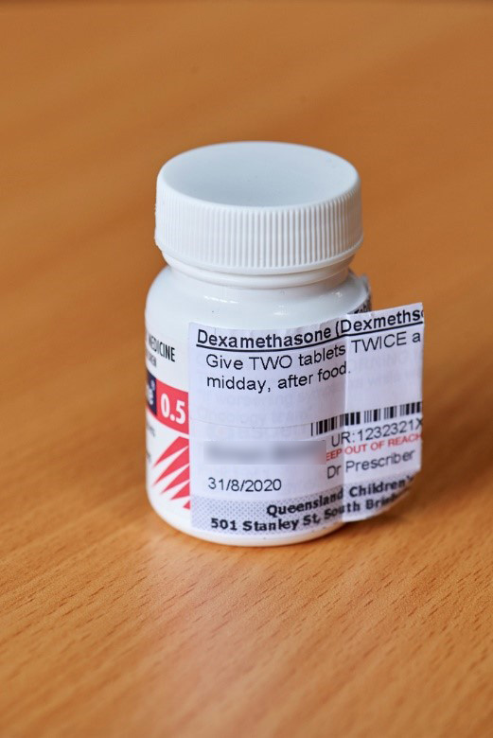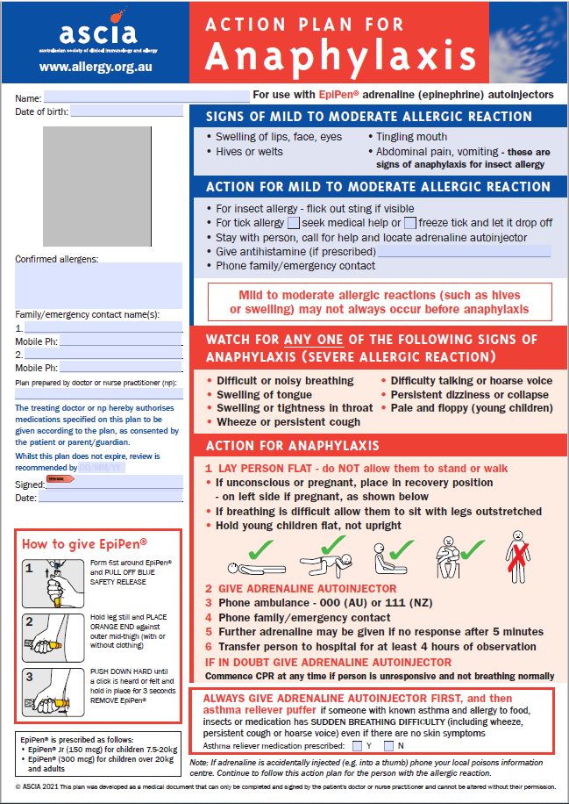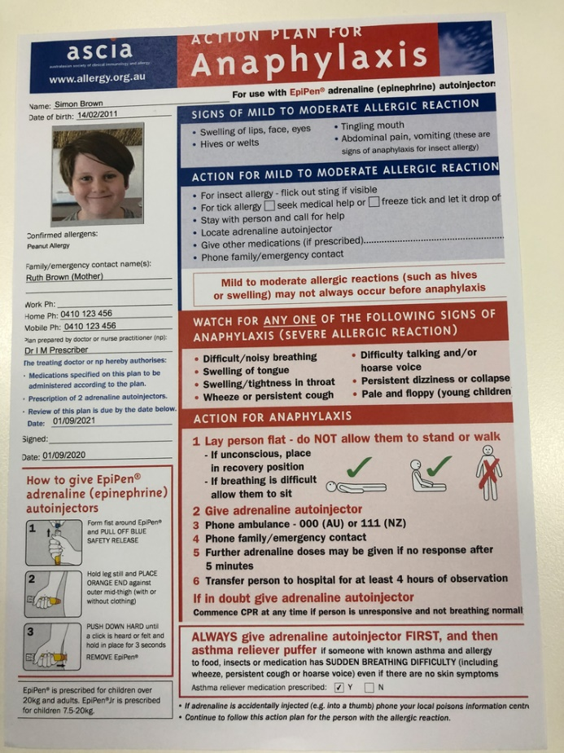

Diagram 1: Pharmacy label check:

Checking the pharmacy label
Schools can confirm that medication has been prescribed for a student by checking the following.
Check that the name of the medication and dosage matches the written advice from parent/carer and health practitioner.
Check that the name on the label is the student to whom it is to be administered.

BRAND NAME OF MEDICATION <strength and quantity/volume of dispensed medication>
(Name of medication)
<Directions for use including specific times when medication is to be taken>

<NAME OF STUDENT> III IIIII III IIIII III IIII II
<Date dispensed> <Name of prescribing health practitioner>
<Price>
KEEP OUT OF REACH OF CHILDREN
--------------------------------------------------------------------------------------------------------------------------------------------
<Pharmacist business details>

IMPORTANT
Check that a qualified health practitioner is listed on the label. If a qualified health practitioner is not listed on the label, medical authorisation will need to be confirmed with other written documentation from the health practitioner or by contacting the pharmacist. When there is no health practitioner name, it is likely that the medication has been purchased over the counter. To administer this medication, additional medical authorisation (e.g. a medication order) will be required.

Written medication authorisation
Medical authorisation can also be:
- a signed letter from the prescribing health practitioner, or
- a Medication order to administer ‘as-needed’ medication at school, or
- a completed and signed health plan from the treating health practitioner.
These documents need to outline the same type of information that would be found on a pharmacy label i.e. student’s full name, clear and detailed directions for taking the medication and contact details for the health practitioner.

If medical authorisation cannot be confirmed
If appropriate medical authorisation cannot be confirmed, school staff will not administer the medication. For the medication which is legally prescribed and needs to be administered during school hours, parents/carers will have to attend school personally to administer medication to their child until appropriate medical authorisation can be provided to the school.

Receipt and transport of medications
Parents/carers should be encouraged to provide and collect students’ medication in person. Where this is not possible, the school should discuss with the parent/carer other safe methods of transporting the medication e.g. if the student is transporting their own medication, they must deliver it to the office on arrival at school.
For students who use Specialist School Transport (SST), parents/carers are responsible for arranging the provision of medication to the school office.
In exceptional cases, where the parent/carer has exhausted all options to get the medication to the school office, a request may be made to the SST operator to transport the medication. The parent/carer needs to advise the SST operator of any special requirements for transporting the medication i.e. temperature control, fragile handling, storage in a secure area. The SST operator is under no obligation to agree to transport the medication for handover to school office staff.

Temperature control
Insulated bags may need to be used to transport medications that require refrigeration or need to be kept at a certain temperature.

Original container and intact packaging
Medication should always be supplied to the school in its original container with the internal packaging intact i.e. sealed foil strip, sealed blister pack. Where packaging of individual medications is not intact i.e. the foil is no longer sealed around the tablet, the safety of the medication could be compromised. Do not administer this medication and alert the parent/carer to this situation.
The only time that medication may not be supplied to the school in its original container is when a pharmacist has used a dose administration aid (DAA). While this is not the medication’s ‘original container’, it has been packed by the pharmacist and will be a tamper-evident, well-sealed device or system that allows for the organising of doses of prescribed medication according to the time of administration.
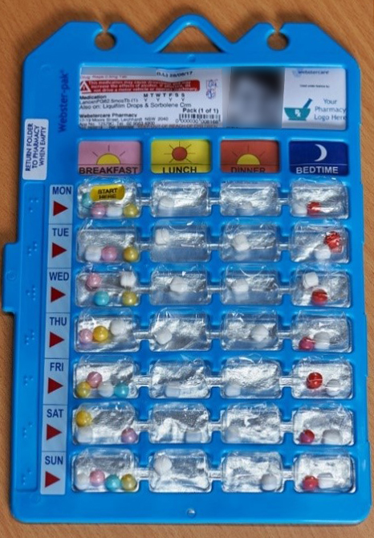
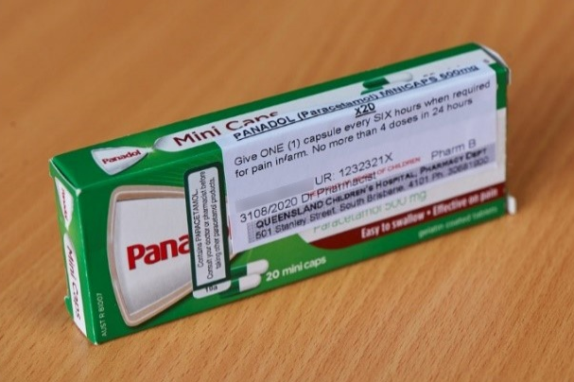

Image 2: Example of original container with intact packaging

Image 3: Example of dose administration aid

Administration of medications
Medication can be administered either by school staff or by the student themselves.

Staff administration
Following best practice when administering medications ensures that the right student receives the right dose of their medication at the right time by the right route.
Processes for administering medication to students may vary from school to school, depending upon students’ individual needs, the school’s size and layout, and the ability of staff to easily identify students.
The 7 RIGHTS of safe medication administration in schools (Appendix 2) are the measures expected to be applied in all state schools.
When possible, it is also ideal for the same staff member to be responsible for preparing, administering and recording the medication administered to a student. These tasks should all be done without distraction, ideally consecutively, to minimise the risk of errors.

Student self-administration
Contemporary management of chronic health conditions encourages students to build independence, recognise the signs and symptoms of their health condition, and administer their own prescribed medication, either routinely or as needed.
However, NO student should be solely responsible for self-administering emergency medication, as their symptoms may compromise their ability to do so.

Controlled drugs
The principal CANNOT approve students who require Ritalin or dexamphetamine (or other controlled drugs) to personally manage and self-administer this medication. These medications must be stored securely in a locked location (e.g. locked cabinet or drawer) when not being administered. They must only be administered by authorised school staff.

Routine medications
Some students require routine administration of medication to manage their health condition. These may include:
- the injection of insulin for diabetes;
- inhaling preventative medication such as Ventolin for asthma;
- orally administering enzyme replacements for cystic fibrosis; or
- applying medicated ointment to the skin.
The principal/delegate, in consultation with the student, their parent/carer and their health team, can implement an approval process to allow a student to self-administer their medication, with the exception of controlled drugs (refer to Appendix 3 for the approval requirements for self-administration).

Even when a student is competent at self-administering their medication, the principal/delegate should also consider and assess any additional associated risks at the local school level in determining if it is safe for the student to self-administer their medication, and additional safeguards that may need to be put in place e.g. some medication may be kept with the student (e.g. Ventolin), whereas some medication will need to be stored securely, but not locked, when not in use (e.g. insulin pen).
A risk assessment approach (refer to Appendix 4) should be used by the principal/delegate to assist the consideration of any potential risks associated with students’ self-administering medication.
Teachers can assist students to manage their health condition by incorporating their medication needs in the routine management of the class and school (e.g. remind the student to go and put their eye drops in, allow the student with diabetes to eat a specific snack before their PE lesson in order to manage their carbohydrate levels). The school must take into consideration the student’s confidentiality and privacy.

Asthma medication
As asthma is a common childhood health condition which is treated by inhaling medication from an easy-to-use device, many students can self-administer their own medication without adult support or supervision. Asthma medication can be administered routinely to prevent symptoms, or as an emergency medication in response to certain symptoms.

Requirements for self-administration of asthma medication
A parent/carer can advise the school administration of their decision to allow their child to be responsible for self-managing their asthma if a parent/carer believes that their child can:
- confidently, competently and safely administer the right dose of their own asthma medication at the right times
- can store their medication securely, and
- is aware of the importance of attempting to notify staff if they feel symptoms and intend to self-administer their medication, but not to delay self-administration if they can’t notify a staff member in time.
For primary school students, the principal/delegate is required to complete a risk assessment (refer to Appendix 4), considering the maturity of the student. NOTE: Use caution when considering requests in relation to young students e.g. those under 10 years of age.
As secondary school students are older and likely to be more experienced in administering their medication, the parent/carer can approve for their child to self-administer their asthma medication without the need for principal/delegate approval. Likewise, an independent student or a student over the age of 18 can nominate to self-administer their asthma medication.
The principal/delegate may overturn a parent’s/carer’s/student’s decision at any time if there are any significant risks associated with the student self-administering medication during school or school-related activities.
If a student is approved to self-administer their asthma medication, the enrolment officer/student information officer will record the parent’s/carer’s/student’s decision in OneSchool and will not require an Asthma Action Plan, unless the first aid response varies from the standard asthma first aid response.
The school will need a copy of a student’s Asthma Action Plan if staff are administering or supporting the student to administer the asthma medication, or if their emergency response is complex (e.g. student requires several medications).
If a student is unable to self-administer their medication in an emergency and requires assistance, trained staff will provide Asthma First Aid.

Adrenaline auto-injectors
Adrenaline auto-injectors (e.g. EpiPen) are easy-to-use devices that can be easily administered by non-medical personnel. Instructions to administer these are on the device and in the student’s Anaphylaxis Action Plan that should always be kept with the medication.
The principal/delegate, in consultation with the student, treating team, and the student’s parent/carer (if under 18 years old), may approve for a student to carry their auto-injector on their person and self-administer this medication if all of the following can be confirmed:
- the student can always carry their own medication safely and securely;
- the student can safely store their medication (with their Action Plan);
- the student keeps their medication in-date;
- the student is aware of their warning signs and the importance of notifying the nearest person to advise supervising staff of the situation;
- staff are aware that the student is carrying emergency medication; and
- staff who supervise the student are familiar with their warning signs (as per their Action Plan) and are trained to administer the emergency medication if the student is unable to do so.
In making their decision, the principal/delegate should also assess any associated risks at the school level.

Emergency medications (other than for asthma or anaphylaxis)
For students with health support conditions (other than asthma and anaphylaxis) who may require emergency medication, consultation with the student’s treating team, parent/carer and a State Schools Registered Nurse will determine if self-administration is an option. If so, requirements will be documented in the student’s Emergency Health Plan.

Supervision of students who self-administer their own medication as an emergency response
A student who has been approved to self-administer their own medication in response to an emergency (e.g. asthma reliever or adrenaline auto-injector) will carry this medication on their person. However, in an emergency, a student’s symptoms may compromise their ability to self-administer their medication effectively.
Staff supervising students who self-administer their emergency medication should be familiar with warning signs (as per their Action Plan or Emergency Health Plan) and be trained and prepared to administer the emergency medication if the student is unable to do so.

Insulin administration
Students with type 1 diabetes require daily diabetes treatment regimens which include insulin administration. Due to the wide range of devices used and methods for calculating insulin doses, the school requires:
- the Consent to administer medication form
- a medication order or written advice from the prescribing health practitioner identifying and authorising the administration of insulin, and the method for determining the dose; and
- a diabetes management plan completed by the treating health practitioner and/or the student’s diabetes treating team (e.g. Paediatrician, Endocrinologist, Credentialed Diabetes Educator [CDE]).
- The diabetes management plan will be used by the department’s State Schools Registered Nurse, or CDE, in consultation with the school and parent, to support the student’s diabetes management during school and school-related activities.

Image 4: Examples of three types of documents that provide the authorisation for the school to administer insulin.

Medication order / Advice from prescribing health practitioner
xxxx
xxxxx
xxxxxx
Xxxxxxxxxxxxxxxxxxxxxxxxxxxxxxxxxxxxx
Xxxxxxxxxxxxxxxxxxxxxxxxxxxxxxxxxxxxx
Xxxxxxxxxxxxxxxxxxxxxxxxxxxxxxxxxxxxx
Xxxxxxxxxxxxxxxxxxxxxxxxxxxxxxxxxxxxxx
Xxxxxxxxxxxxxxxxxxxxxxxxxxxxxxxxxxxxxx
Xxxxxxxxx
Dr Xxxxxxxxx
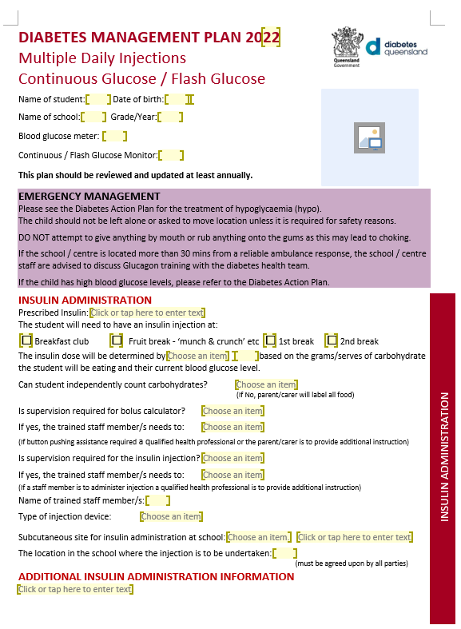
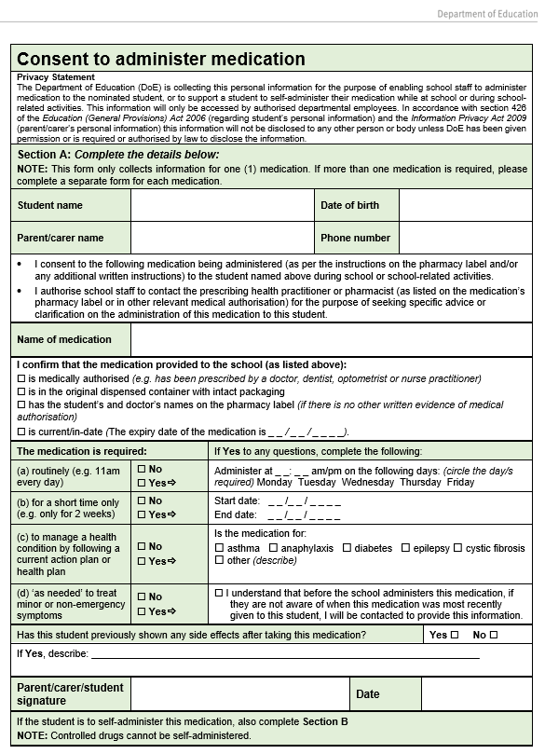

Storage
Medications come in a variety of forms (e.g. drops, creams, tablets, injectable liquid, suppositories) and have their own storage requirements in order to maintain shelf-life and be effective.
Risks associated with storing medications on school property, include:
- loss (e.g. through spillage or poor management);
- theft or misuse by those for whom they were not prescribed;
- deterioration due to incorrect storage;
- access issues, especially for emergency medications; and
- expiry of medication.
To reduce these risks, schools should:
- store medications according to their specific requirements (see Appendix 1), with consideration to the safety of the student and the school community, the frequency of their administration and the requirements in student health plans; and
- implement a process to monitor medication expiry dates and ensure sufficient supply.

NOTE: Emergency medication:
- MUST NOT be stored in a locked location (e.g. cupboard/classroom) as delays in giving emergency medication can result in death
- needs to be portable to respond to a medical emergency
- may need to be stored in a portable insulated wallet.

Dose administration aids (DAA)
Parents/carers may provide their child’s medication to the school in a dose administration aid (DAA) such as a sachet system, blister pack or bubble pack. The DAA labelling will include the child’s name, the date and time of administration, the name and dosage of the medication and the pharmacy details. While it will not include the name of the prescribing health practitioner, it is unlikely that a pharmacist would provide medication in a DAA that hasn’t been prescribed.
If the school wishes to seek confirmation of medical authorisation for medication in a DAA, the parent/carer can provide a medication profile (from the pharmacy) or the school can contact the pharmacy.
Having medication packaged in a DAA can assist schools to easily store and safely administer medication, and enables parents to only provide the school with the medication required to be administered there. A DAA reduces the risk of loss or theft by eliminating the need for parents/carers and/or schools to count out loose tablets from bottles.

Pill-cutters
Where the dosage of a medication requires tablets to be halved, schools are to request that parents/carers supply a pill-cutter, labelled with the student’s name. The pill-cutter is to be stored with the student’s medication and not used for other student’s medication – to reduce the risk of cross-contamination. The remainder of a cut tablet is to be returned to the packaging.

Disposal
Medication must be disposed of carefully and responsibly. It must not be disposed of down a sink or into the rubbish.
When medication is initially brought to the school, advise the parent/carer that they will need to collect any unused medication when it is no longer required to be administered at school.
When the period of administration is finished, remind the parent/carer to collect any remaining medication.
When medication has passed its expiry date and cannot be administered – ask the parent/carer to collect it for disposal.
Any unused medication that has not been collected by the parent/carer must be taken to a pharmacy for disposal e.g. through the Return Unwanted Medicines project. The pharmacy will ensure that all medication (including controlled drugs) are disposed of correctly and in accordance with the law.
Sharps must be disposed of in a sharps disposal kit (refer to the guidelines in the Safe Handling and Disposal of Needles and Syringes).

Camps and excursions
An essential part of planning for camps and excursions is ensuring that systems are in place so that students who require medications receive them.
Prior to the camp/excursion:
- advise parents/carers well in advance that all medication requires appropriate consent and medical authorisation;
- identify students with health support needs to determine and plan for medication requirements with their parent/carer and qualified health practitioner (e.g. State Schools Registered Nurse);
- refer to the Anaphylaxis Guidelines for Queensland State Schools , Diabetes Guidelines for Queensland schools and Asthma Guidelines for Queensland Schools for specific advice to plan for camps/excursions that students with these health conditions will attend;
- check the availability of, location of, and distance to emergency services or hospitals;
- ensure there will be access to power at the camp/excursion location to recharge medication delivery devices e.g. nebulised medication;
- identify which students self-administer their medication and any associated requirements;
- identify any requirements for storage and transportation of the medications e.g. insulated wallet, approvals for taking medications on a plane;
- ensure that emergency first aid medications are available during travel to and from, and at a camp/excursion location for the duration of the event;
- consider maintaining a register of medications;
- advise all staff supervising students with health conditions of their symptoms and health needs; and
- ensure the relevant documentation will be available (e.g. recording sheets, medication orders) for the duration of the camp/excursion.
During the camp/excursion:
- ensure only authorised staff have access to documentation and medication
- administer medication referring to the 7 RIGHTS of safe medication administration.
After the camp/excursion:
- return all unused medication to parents/carers
- store all camp/excursion documentation as per the Records management manual (DoE employees only).

State school operated residential boarding facilities
All responsibilities and processes outlined in the Administration of medications in schools procedure and its supporting documents, including this guideline, apply to Queensland Department of Education state school operated residential boarding facilities.

Specific advice regarding medicinal cannabis
Under the Medicines and Poisons (Medicines) Regulation 2021 (Qld), schools can manage and administer medicinal cannabis in the same manner as other prescribed medications in schools.
If a parent/carer requests that the school administer a medicinal cannabis product to their child, it must be prescribed by a prescribing health practitioner and dispensed by an approved pharmacist.
The prescribed medication should be managed as a controlled drug.
If the school is concerned as to whether a medicinal cannabis product is legal, the principal/delegate contacts Queensland Health’s Office of Medicinal Cannabis at MCTeam@health.qld.gov.au for advice.
If the medication is illegal and a staff member is aware of its presence in the school, they must inform the principal.
- If the student has the medication, the principal is to deal with the substance under the Temporary removal of student property by school staff procedure.
- If a parent/carer has brought the medication on to the school grounds, the principal is to notify the police.
For further information, visit the Queensland Health website at https://www.health.qld.gov.au/public-health/topics/medicinal-cannabis.

Specific advice about chemical restraint
As per the Restrictive practices procedure, school staff must not use any chemical restraint to control or subdue a student's behaviour. School staff may only administer medications that are prescribed by a health professional for the student in accordance with the Administration of medications in schools procedure.

Appendix 1: Considerations for storage of medications

The following table provides examples of storage locations in the school environment.
Type of medication | Considerations for storing medications
All medications | Store safely, considering a student’s individual requirements and in accordance with manufacturer’s instructions.
Controlled drugs | Always store securely in a locked location (e.g. locked cabinet/drawer) when not being administered.
Enzyme replacements and salt tablets for cystic fibrosis | Keep in proximity of the student so that they consume them with their meals.
Emergency first aid medication | Keep in the most accessible school first aid kit/s.
Adrenaline auto-injector | Store in an unlocked location for easy access in an emergency. Store out of direct heat and sunlight and below 25ºC. Do not leave exposed in non-air-conditioned locations for extended periods of time e.g. over summer holidays. Do not refrigerate or store with ice/freezer blocks as this may jam the mechanism.  In regions where temperatures regularly exceed 25ºC, an insulated wallet is recommended to reduce exposure of the auto-injector to extreme temperatures.  The school’s auto-injector/s are to be stored with an ASCIA Action Plan for Anaphylaxis (ORANGE) that provides instructions on their use.  The student’s auto-injector is to be stored near the student in the student’s anaphylaxis emergency kit with their personal ASCIA Action Plan for Anaphylaxis (RED). The emergency kit should be taken with them when participating in school activities.
Asthma reliever/puffer and spacer | Store in an unlocked location for easy access in an emergency.  The school’s asthma reliever and spacer/s are to be stored with a copy of the Asthma First Aid plan that provides instructions on their use.
Insulin injectors | Store in an unlocked location for easy access when required. Manage risks associated with sharps when determining storage locations.
Situation | Considerations for storing medications
Locked medications | The principal/delegate will determine which officers have access to the locked location to manage storage and enable appropriate administration of medications.
Refrigerated medications | Do not store medication in a fridge that students or unauthorised personnel may access. Consider having a separate fridge for medications.
During an evacuation or fire drill | Students’ emergency medications are to be stored in a manner that allows them to be safely and easily transported with the relevant student e.g. waist bag / hip pack.
During school holidays | When storing medications over holiday periods, ensure they are stored in accordance with manufacturer’s instructions. For medications requiring refrigeration, consider how disruptions to the power supply will be mitigated/managed. At the end of the school year, individual students’ medications should be collected by the parent/carer where possible.
Medication kept with the student | Some students require medication to be kept with them (or close by) to manage their individual health needs.

Appendix 2: 7 RIGHTS of safe medication administration in schools
The 7 RIGHTS of safe medication administration in schools are based on best practice. Following these 7 RIGHTS reduces the risk of errors occurring when administering medication to students.
If any of the following RIGHTS are unable to be met – DO NOT administer the medication and seek advice from the principal/delegate.
- HAVE YOU GOT THE RIGHT DOCUMENTATION?
On receipt of the medication, check that:
there is medical authorisation for the medication
the completed Consent to administer medication form is current and legible
any forms completed by the prescribing health practitioner (including medication orders or written advice) are current and legible.
Before administration, check that:
you have selected the correct record form to use (i.e. routine or ‘as needed’)
you have securely attached all necessary forms together (e.g. consent form, record form, additional information)
the principal/delegate has reviewed the information and assigned administration to the appropriate staff member.
After administration, check that:
you have completed and signed the Record forms immediately after the administration of medication to the student
you have stored the documentation securely (as it contains confidential information).
If there has been a medication error, check that:
you have documented the medication error as per Appendix 6

- DO YOU HAVE THE RIGHT STUDENT?
Indicate below how your school requires you to clearly identify the student and ensure it is the right student for the medication. (Note, you may select more than one.)
This can be done in several ways – depending on the school environment, staff familiarity or turnover, student capability, students with similar names / ages / medications.
Examples of when this approach is suitable: | How:
- if there is a larger student population  - if there is a change to staff administering medication e.g. relief staff | by the student stating their name and date of birth
- if the student is unable to verbalise their name and date of birth | by matching the student to their photo attached to the record form
- if students in the school have similar names | by two-person check
- if it is a small school with a known student population  - if the same staff member administers medication every time | by sight

- DO YOU HAVE THE RIGHT MEDICATION?
On receipt of the medication, check that:
the medication has been provided in the original packaging
the information on the medication container matches with the documentation e.g.
- student’s name
- directions for administration including dosage, times and route.
Before administration, check that:
the medication will be administered directly from the original container
the medication has not been removed from the original container/packaging/foil/bottle
the medication has not been altered in size prior to being provided to the school (e.g. tablets halved).

- ARE YOU ADMINISTERING THE RIGHT DOSE?
Before administration, check that:
the amount of medication to be administered to the student is clearly written on the prescription label e.g. 10 mL or 1½ tablets
the strength of the medication (the amount of active ingredients available in 1 dose, e.g. 250 mg/5 mL) is clearly written on the prescription label and matches the medication order or information provided by the prescribing health practitioner
for medication where the student’s dosage is being varied (e.g. insulin, Ritalin), the current medication order or health plan provided by the prescribing health practitioner is always referred to (as the pharmacy label may not be current). Seek clarification from the parent/carer/health practitioner if unsure
for injectable medication or a controlled drug and where possible, two people have checked the medication order prior to administering. Note: for a student who is self-injecting their medication, only one staff member is required to confirm the dose.
After administration, check that:
the student has consumed the medication e.g. swallowed the tablet.

- ARE YOU ADMINISTERING THE MEDICATION AT THE RIGHT TIME?
Before administration, check that:
it is right time to administer the medication as per the Consent to administer medication form
for camps, the time on the Consent to administer medication form to confirm ‘am’ or ‘pm’
the medication is administered at an appropriate time in relation to special instructions e.g. at meal breaks for medication to be taken with or after food
the medication is administered after a specific time in relation to the previous dose e.g. every four hours
when ‘as-needed’ medication is administered as a non-emergency response (e.g. Panadol for a migraine), instructions on the medication order have been read and will be followed. If the time of the most recent dose is not known, seek timing advice from the parent/carer, and confirm with the principal/delegate whether or not to administer the medication using all information provided
medication is only removed from the original container immediately prior to administration to reduce the possibility of deterioration or loss.

- ARE YOU ADMINISTERING THE MEDICATION VIA THE RIGHT ROUTE?
Before administration, check that:
the medication will be administered as per the route identified on the prescription label and/or the medication order provided by the health practitioner
the advice will be followed on the student’s health plan if the student has any barriers to the medication being administered via the right route e.g. student vomiting and unable to swallow oral medication, student not staying still for injection.

- ARE YOU STORING AND DISPOSING OF MEDICATION IN THE RIGHT WAY?
Check that:
controlled drugs are stored securely in a locked location when not being administered
medication is stored in accordance to manufacturer’s instructions e.g. stored at a certain temperature, out of direct heat and sunlight
medication is stored in a location that meets the student’s individual requirements e.g. with student, in the classroom, in the first aid kit
all medication is in-date (i.e. has not passed the expiry date)
sharps are stored and disposed of correctly and safely
medication that is no longer required by the school is collected by parent/carer or is taken to a pharmacy for disposal.

Appendix 3: Approval requirements for self-administration
The following table outlines the approval requirements for different medication types and student groups, and any restrictions to be implemented.
Type of medication |  | Is school approval required? | Restrictions
Controlled drugs |  | Not applicable | Students cannot be approved to self-administer controlled drugs
Routine | Short term | Yes - Principal/delegate | -
 | Long term | Yes - Principal/delegate | -
 | Asthma preventer medication  - primary students | Yes - Principal/delegate | Use caution when considering requests in relation to young students e.g. those under 10 years of age
 | - secondary students | No - Parent/carer/student decision | -
As needed | As an emergency response for asthma  - primary students | Yes - Principal/delegate | Use caution when considering requests in relation to young students e.g. those under 10 years of age
 | - secondary students | No – Parent/carer/student decision | -
 | As an emergency response for anaphylaxis | Yes - Principal/delegate | -
 | As a non-emergency response | Yes - Principal/delegate | -

Appendix 4: Risk assessment for determining self-administration
This process may be used to assist the principal/delegate in assessing the risks associated with approving a student to carry and administer their own medication.
All staff are required to manage risks as part of day-to-day activities and principals/delegates are to note that the department has the lowest appetite for risks associated with the safety of children and students (refer to the Enterprise Risk Management Framework).
NOTE: Students cannot be approved to self-administer controlled drugs.
Parents/carers of secondary school students with asthma may determine if their child can self-administer their medication without principal/delegate approval. However, this checklist may be used with parents/carers if they would like assistance in making this determination.
In determining whether a student can self-administer medication, the principal/delegate should (at a minimum) consider the factors in the table below, in consultation with parents/carers, the student and the student’s health team.
If a response to the factors below is “No”, advise the parent/carer and student that self-administration will not be approved.
FACTORS FOR CONSIDERATION | Yes/No
The student can:
- follow a timetable for administering medication (where it is required routinely at set times)
- recognise signs and symptoms that indicate they need to administer their medication (when it is required ‘as-needed’)
- confidently, competently and safely administer their own medication following all instructions (e.g. on pharmacy label, in health plans)
- follow infection control guidelines
- demonstrate safe storage of medication as medication may be potentially harmful to other students
- demonstrate appropriate storage of medication e.g. when medication is required to be kept at a certain temperature
- safely dispose of sharps, equipment or other medication consumables (where relevant)
- ensure their medication is in-date.
Other students who are in the proximity of a student self-administering can behave appropriately to maintain a safe and respectful environment for the student self-administering medication.

Appendix 5: Responding to medication side effects, errors and incidents
Follow the process below if:
- a medication error has occurred (e.g. the incorrect medication or dosage has been administered); or
- a student has consumed unauthorised medication (e.g. stolen or shared medication).
Incident | Phone | Response
Medication error with the student showing no observable adverse reaction | Poisons helpline  13 11 26 | - Notify the principal/delegate*  - Phone 13 11 26 (Poisons helpline) and follow their advice  - Advise the parent/carer  - Continue to monitor student if they remain on school site.  Note: If the student’s condition deteriorates while on the phone to the Poisons helpline. they will transfer you to Emergency services.
Medication error and/or side effects with the student showing a severe reaction such as any of the below:  - collapsing  - not breathing or difficulty breathing  - severe nausea or vomiting  - a face that turns pale  - another severe reaction (e.g. hives, swollen lips, sweaty skin, chills) | Emergency services  000 | - Notify the principal/delegate *  - Provide first aid  - Phone 000  - Request ambulance services and follow their advice  - Have medication and student’s health information details ready to provide to the ambulance services  - Contact the parent/carer.
Student has consumed unauthorised medication with or without an observable reaction. | Emergency services  000 | - Notify the principal/delegate *  - Provide first aid (if needed)  - Phone 000  - Request ambulance services and follow their advice  - Have medication and student’s health information details ready to provide to the ambulance services  - Contact the parent/carer.
* NOTE: If you are unable to notify principal/delegate immediately, DO NOT DELAY in providing first aid or phoning health/emergency services.

Appendix 6: Recording actions following medication side effects, errors and incidents
Incident/Cause | Result | Record
A. Medication error occurred with the student’s medication  e.g. incorrect dosage, missed dosage, incorrect medication | Student became ill  OR  Student did not become ill | - Record contact with the parent/carer as a ‘record of contact’ in OneSchool; and  - Record the incident in MyHR Home > Workplace Health and Safety > Add New Incident>Injury/ Illness).  Note: Do not record an incident where the student was not ill as a ‘near miss’, as this field does not record student details.
B. Emergency medication required due to workplace factor (i.e. curriculum activity)  e.g. asthma attack due to science experiment fumes, anaphylactic reaction due to exposure to allergen | Emergency medication administered (either the student’s or school’s) | - Record the details of the event described to the parent/carer as a ‘record of contact’ in OneSchool; and  - Record the incident in MyHR Home > Workplace Health and Safety > Add New Incident> Injury/illness tab.
C. Emergency medication required but NOT due to workplace factor  e.g. undiagnosed student has asthma attack in playground | School’s first aid emergency medication administered for asthma attack or anaphylactic reaction | - Record contact with the parent/carer as a ‘record of contact’ in OneSchool; and  - Record the incident as per Recording first aid in the Managing first aid in the workplace procedure.
D. Student experiences a reaction / side effects to their own medication | Mild → non -emergency response | - Record contact with the parent/carer as a ‘record of contact’ in OneSchool.
 | Severe → medical treatment required e.g. taken to doctor or hospital | - Record contact with the parent/carer as a ‘record of contact’ in OneSchool.
E. Unauthorised consumption of medication i.e. student has consumed stolen medication, medication has been shared with others | Student became ill  OR  Student did not become ill | - Record contact with the parent/carer as a ‘record of contact’ in OneSchool; and  - Record the incident in MyHR Home > Workplace Health and Safety > Add New Incident > Injury/ Illness);  Note: Do not record an incident where the student was not ill as a ‘near miss’, as this field does not record student details.  - If first aid provided, record the incident as per Recording first aid in the Managing first aid in the workplace procedure;  - If police involved, record contact with police as a ‘record of contact’ in OneSchool.

