How to complete an EQ38 Form

Overview

Forms MUST BE completed in full. If not, delays in processing your claim will result.

If completing the form electronically, check boxes () can be checked by right clicking on box, selecting properties and changing the default value to “checked”, then select OK.

Completion of EQ38 form should occur within forty-eight (48) hours of the incident.

Claim form EQ38 is submitted within two (2) months of incident, or three (3) months if over Christmas holiday break.

Section 1 – General information
- Ensure that ALL school and contact details are entered.
- Date of Loss: This field is mandatory and is the date of the incident (a date range is not acceptable and will delay processing of the claim). If unsure, use the most accurate date known after consultation with the key stakeholders (e.g. police etc.)
- Time of Loss: Indicate with a in the correct incident’s time frame (e.g. 4pm-8am)
- Area of Loss: Clearly identify the building/s and room number/s where the incident occurred (e.g. E Block – Rooms E1 & E4). If the incident occurred outside the school grounds, provide the full address of where the incident occurred, e.g. if a teacher’s CFT laptop stolen from their home address, therefore the home address is required.
- Cause of Loss: Indicate with a in the relevant category. If selecting ‘other’, ensure sufficient details are provided to allow the Resource Replacement Scheme (RRS) to make a determination as to the cause of loss. ‘Other’ may include storm damage, flood damage, mini tornado, etc.
- Estimated Cost: An estimate of the full cost of the incident is required. For example, should your school have been affected by a break and enter, then you would need to include any repair costs to the building (repairs only to be undertaken by BAS), and include estimates of lost resources and any personal claims.
- BAS Work Request No: Enter any BAS Work Request Numbers here (e.g. if you have called BAS to repair a broken window, as a result of a break and enter). Information can be obtained by contacting your BAS Senior Program Supervisor or by logging onto OnePortal (to access your school’s maintenance notifications). If work order numbers and copies of job statement sheets are not able to be lodged with the initial notification, write TBA (to be advised) and provide at your earliest convenience.
- Claim Purpose: This is where you indicate whether you are lodging this claim for notification purposes only or whether you are seeking compensation for lost items.

Police notification details ***Must be completed in Full***
- Police Station: If the police have been called, enter the police station that responded to your call or enter Policelink.
- Officers Name: Enter attending police officer’s name.
- Date: Represents the date you contacted the police to notify them of the incident.
- Crime Number: This is a number issued by police (including Policelink) to register your incident. This number must be entered in order to process the claim.
- Does any person other than the Department of Education and Training (DET) have an interest in the lost/damage items? Indicate Yes or No – If insufficient space attach additional details including a list of items lost and to whom they belong (e.g. teacher).

Section 2 – Risk management ***Must be completed in Full***
DET has adopted the strategy of risk management in accordance with Australian Standard 31000:2009. To ensure adherence to this strategy, provide answers to ALL QUESTIONS in this section by ticking Yes or No. To assist with answering the last four questions in this section, the following information has been included.
- Has the school been visited recently by a school security advisor? Yes or No (Your school security advisor can assist you after an incident so it is advisable to contact them. If uncertain of your school security advisor, call RRS and they will assist you with contact details).
- How was entry gained? (e.g. through window/door) – Include all details of entry – if insufficient space attach additional information
Example - bars on windows bent and glass smashed.
- What damage occurred at the point of entry, including what occurred during the incident? Provide sufficient information to “paint the picture” of what occurred. Include a statement detailing how entry was gained to each area and what occurred during the incident, where the items were located in each room and whether they were secure. If insufficient space attach additional information.
Example 1: Vandals broke windows and jemmied the door. Majority of classroom items on benches were dispersed all over the room. Classroom paint kept in storeroom (storeroom not locked) splashed all over desks and chairs and carpet. Fire extinguisher set off and sprayed around room.
Example 2: Mini tornado ripped through the school and damaged 1 building and 2 shade sails. A Block NW corner of roof torn off (no internal damage) and 2 shade sails completely torn off.
- What steps have been taken to prevent a recurrence? Note any security measures taken to prevent incident occurring again - if insufficient space attach additional information.

Example: Storeroom to be locked prior to departure and school security advisor consulted.

Section 3 – Declaration ***Mandatory***
- Must be signed and dated only by the principal or deputy principal of the school. Forms signed by a business services manager unfortunately will not be accepted.

Section 4 – Details of equipment and materials stolen

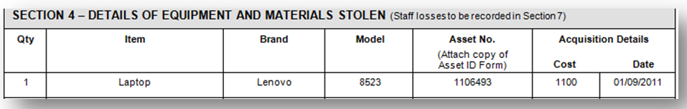
- Each item must be listed separately and MUST be accompanied by quotes/invoices for the replacement of each item. The claim cannot be processed without this information. If insufficient space, list further items on page 3 or attach additional information.
- Asset ID printouts from OneSchool are compulsory for each item over $100.00 in accordance with Equipment management for schools or Equipment management for business units. Claims cannot be processed until printouts are provided.

Section 5 – Details of equipment and materials damaged
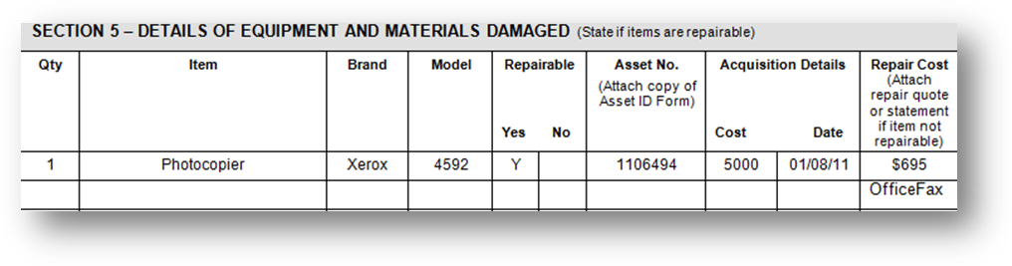
- Each item must be listed separately and MUST be accompanied by quotes/invoices to ensure that the claim is processed. If insufficient space, list further items on page 3 or attach additional information.
- An independent assessment is required on electronic devices and those which run on fuel. The costs associated with the independent assessment can be lodged as part of your claim. Please liaise with the RRS team if unsure of what is required.
- Provide photographs of the damaged items/equipment with your claim.

Section 6 – Details of cash stolen

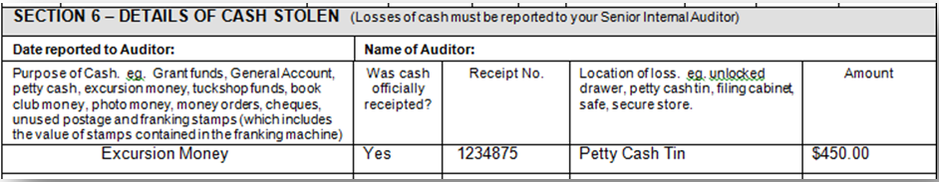
- Cash losses must be reported to your senior internal auditor. The date the loss was reported to the senior internal auditor (SIA) and the SIAs name are required.
- Each item must be listed separately – petty cash, book club money, etc. If insufficient space, list further items on page 4 or attach additional information.
- Receipted funds require a copy of the receipt and itemised monies.

Section 7 – Details of staff member losses

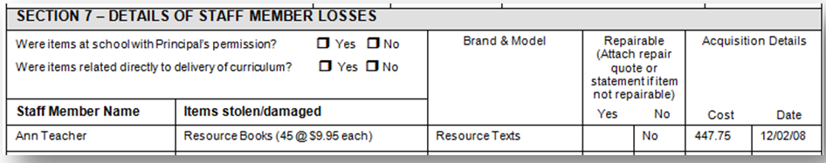
- Only curriculum related items are claimable and proof of purchase is required. Personal items e.g. sunglasses, briefcase etc. will not be covered.
- Items have to be listed separately. If insufficient space, list further items on page 4 or attach additional information.
- Maximum amount claimable is $1,000.00 per staff member.

If you require further assistance contact the RRS team:
Email: rrs.facilities@det.qld.gov.au
Telephone: 1800 916 770
Or refer to the Resource Replacement procedures located at: http://education.qld.gov.au/schools/grants/state/previous-funded-programs/resource.html

