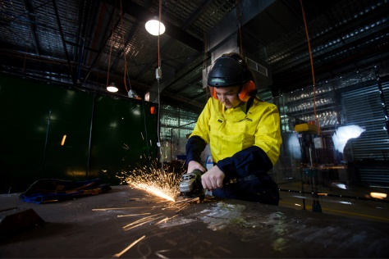
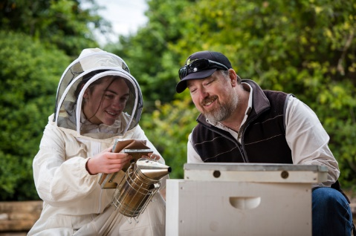
School-based apprenticeships and traineeships (SATs) – Information for parents and carers

What is a SAT?
A SAT enables school students, in Years 10, 11 or 12, to work for an employer and train towards a nationally recognised qualification, while completing their secondary schooling. A student’s timetable or course of study will consist of a combination of school studies, work and training.
What’s the difference between an apprenticeship and a traineeship?
Apprenticeships and traineeships both combine training with paid work in a real job.
Apprenticeships involve training in a skilled trade such as electrical, carpentry, hairdressing, and sign writing leading to a minimum of a Certificate III qualification.
Traineeships involve training in vocational areas such as office administration, tourism, warehousing, and real estate. Upon completion, trainees will receive a minimum of a Certificate II in the chosen vocational area.
Why should my child undertake a SAT?
Participation in a SAT may support your child to:
- gain a head start on their career in addition to paid employment whilst still at school
- work towards their future goals and provide realistic exposure to an industry
- obtain a competitive edge when applying for jobs through the development of workplace skills, knowledge and confidence
- work towards a nationally recognised qualification which may contribute towards their Queensland Certificate of Education
- enter full-time employment, a vocational career, university or other VET training.
How does the school support my child?
SAT arrangements are coordinated by an Australian Apprenticeship Support Network provider (AASN). The AASN will lead negotiations with all stakeholders (the school, student, parent (if under 18 years), the employer, and Supervising Registered Training Organisation (SRTO)) to ensure the SAT schedule will allow the prospective apprentice/trainee to successfully combine school studies, work and training.
The school will also assist the student to access, if eligible, travel and accommodation financial assistance, and tutorial support for language, literacy and numeracy, if required.
Are there any costs associated with participating in a SAT?
SATs in Queensland are funded under User Choice Funding arrangements based on their priority skill level.
There may be some costs associated with undertaking a SAT including training, uniforms, tools and equipment, study materials, transport costs to attend work or training, and travel and accommodation costs to attend training in other parts of the state.
How much time does my child spend in the workplace?
The number of days in paid employment each week is negotiated between the apprentice/trainee, school, employer and SRTO based on minimum paid work requirements unique to the SAT.
The employment can take place during school hours, after school, on weekends and during school holidays. The arrangements must have some impact on the student’s school timetable to be considered a SAT.
Can my child finish their SAT whilst at school?
It is possible to complete a school-based traineeship whilst at school and this would be the aim of most trainees. It is not possible to complete an apprenticeship whilst at school. An apprenticeship generally takes 3-4 years full-time to complete, and results in the apprentice becoming a qualified tradesperson.
On completion of Year 12, it is an expectation that an unfinished SAT converts to a full-time apprenticeship or traineeship.
Looking for further information?
Contact your school’s Senior Schooling team to discuss SATs as a valid pathway option for your child in senior secondary.

