Insert school logo here

School Name

2XXX-2XXX
Prompt Student
Code of Conduct
Equity and Excellence: realising the potential of every student
Equity and Excellence outlines the government's vision for a progressive, high-performing education system. Equity and Excellence provides clarity for schools about priorities and expectations, with differentiated support targeted to each school's context and needs.
Queensland Department of Education

Note 1. This prompt guide is designed to assist in the development of the Student Code of Conduct.

Note 2. The Student Code of Conduct must be developed in consultation with the school community, and a communication plan implemented to ensure existing and new staff, students and parents are fully informed of the expectations and disciplinary strategies in place at your school.

Note 3 A copy of the current, signed Student Code of Conduct must be published on the landing page of the school website. Instructions for this purpose are available from your regional office.

Note 4. Schools must arrange to provide a hard copy of the Student Code of Conduct on request, to a parent, carer or a person who is responsible for a student at the school.

Note 5. Please ensure that all RED text is deleted before converting to PDF and publishing the signed version on the school’s website.

Purpose (Mandated)

Describe what the Student Code of Conduct is for, what it covers and how it supports consistent practice across the school and between schools.

Contact Information (Mandated)

Postal address:
Phone:
Email:
School website address:
Contact Person: | Title of a school-based contact person for further information on the school and its behaviour policies, including reporting bullying.

Endorsement (Mandated)

Principal Name:
Principal Signature:
Date:
P/C President and-or School Council Chair Name:
P/C President and-or School Council Chair Signature:
Date:

Contents (Mandated)

Table of contents with headings and page numbers.

Principal’s Foreword (Optional)
Introduction
Provide overview of school, values and principles and other relevant contextual information. Outline the scope of what is contained within this Student Code of Conduct (e.g. mobile phone policy, anti-bullying strategy, data).

P&C Statement of Support (Optional)

A statement of support from the P&C (or equivalent parent body) is included here to demonstrate the involvement, engagement and collaboration with the parent body in the development of the Student Code of Conduct.

School Captains/Leaders Statement (Optional)

Students in roles as school captains or leaders can present the student body view of the Student Code of Conduct, the consultation and support for the expectations and approach taken by the staff to provide a safe, supportive and disciplined learning environment for all on site.

School Captain Name: School Captain Signature:

Date:

School Captain Name: School Captain Signature:

Date:

School Captain Name: School Captain Signature:

Date:

School Captain Name: School Captain Signature:

Date:

Data Overview (Optional)

This section is used to report on key measures related to student discipline, safety and wellbeing using existing data sets available to all schools. This provides an open and transparent reporting mechanism for the school community on the perceptions of students, parents and staff about school climate, attendance and school disciplinary absences.

The principal is responsible for ensuring that information published maintains the privacy of individual students. For cohort sizes less than five it may be difficult to report certain information and maintain student privacy. Where privacy concerns are evident, principals need to inform their P & C Association and replace the tabular information below with narrative or descriptive comment in each of the categories.

This section should also clearly explain the function of OneSchool, how incidents are recorded and parent access to their child’s OneSchool record. Information about accessing records, reports or timetables is provided here https://www.qld.gov.au/education/schools/information/contact/pages/accessing. Further information about recording incidents in OneSchool is contained in Principal guidelines – student discipline.

Consultation (Optional)

Explain the consultation process used to develop this Student Code of Conduct, the communication strategy in place to distribute and inform all members of the school community about expectations, support and disciplinary consequences.

The Student Code of Conduct should be available for translation, or available as a translated document to accommodate the diverse language needs within your school community. Schools are encouraged to offer short information sessions for families once the Student Code of Conduct has been finalised. These sessions provide an opportunity for families to engage with the Student Code of Conduct through face-to-face discussion.

Learning and Behaviour Statement (Optional)

Outline the school beliefs on student learning and behaviour in this section of the Student Code of Conduct. This should refer to and be grounded in a set of clearly articulated behavioural expectations. To complete this section, schools are encouraged to:
- describe their beliefs about student learning and behaviour, referring explicitly to their behavioural expectations or rules;
- make clear the school’s approach to explicitly teaching expected behaviours and providing opportunities for students to practise the expected behaviours;
- document their three to five brief, positively-stated school expectations or rules.

Student Wellbeing and Support Network

In this section, provide a clear summary of the specific programs and services available at the school or region to students and families. For example, Respectful Relationships, Defence Transition Officers, eSmart School, Student Representative Council etc. The focus should be on highlighting the preventative resources provided to enable students to be safe and successful at school.

Whole School Approach to Discipline (Mandated)

In this section, provide a clear explanation of the whole-school approach to school discipline. This could include explanation of the philosophical position on child development assumed by school staff, the role of teachers in creating and maintaining supportive and safe learning environments, and the way collaborative relationships with parents are established and promoted.

It is recommended that schools draw on the Australian Professional Standards for Teachers – Standard 4 when preparing this overview (covering student participation, managing classroom activities, managing challenging behaviour, maintaining student safety and using ICT safely, responsibly and ethically).

This section also provides another opportunity for the school to explain how a student’s individual circumstances, such as the student’s behaviour history, disability, mental health and wellbeing, religious and cultural considerations, home environment and care arrangements are taken into account when responding to inappropriate behaviour and applying a disciplinary consequence. This should cover how OneSchool records are used, such as Personalised Learning and Support Provisions, to document supports.

Consideration of Individual Circumstances (Mandated)
Detail how the individual circumstances of students are considered by staff when providing support and determining appropriate consequences for disciplinary matters.

Ensure information is included about confidentiality obligations limiting discussion or sharing information about individual circumstances of students, including applied disciplinary consequences, with persons other than the student’s parent/s.

Differentiated and Explicit Teaching (Mandated)

Explain the relationship between differentiation, as detailed in the Assessment and Moderation Hub’s Differentiated teaching and learning, and the school’s discipline model. This could be the section where further detail about how the individual needs or circumstances of students are addressed through reasonable adjustments to teaching, curriculum and assessment. A clear explanation of the three levels of differentiation, differentiated and explicit teaching, focused teaching and intensive teaching as they apply to supporting student behaviour.
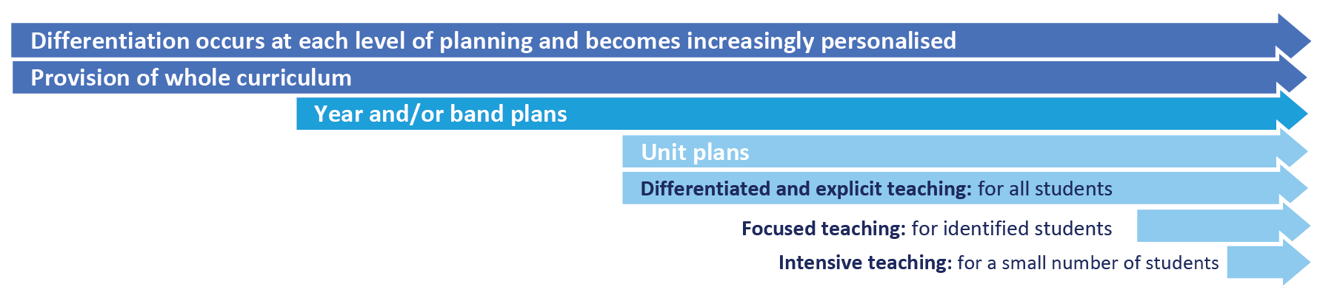

Focused Teaching

Detail the focused teaching provided including additional support to revisit key behavioural concepts and/or skills and explicit and structured teaching strategies. Focused teaching provides students with more opportunities to practise skills and multiple opportunities to achieve the intended learning and expected behaviour.

Intensive Teaching

Unpack the intensive teaching supports involving frequent and explicit instruction for individuals or in small groups, to develop mastery of basic behavioural concepts, skills and knowledge.

For example, a small number of students who continue to display behaviours that are deemed complex and challenging, then individualised, function-based behaviour assessment and support plans and multi-agency collaboration may be provided to support the student.

Legislative Delegations (Optional)
Legislation
In this section of the Student Code of Conduct provide links to relevant legislation that inform the overall Student discipline procedure.

- Anti-Discrimination Act 1991 (Qld)
- Child Protection Act 1999 (Qld)
- Disability Discrimination Act 1992 (Cwth)
- Disability Standards for Education 2005 (Cwth)
- Criminal Code Act 1899 (Qld)
- Education (General Provisions) Act 2006 (Qld)
- Education (General Provisions) Regulation 2017 (Qld)
- Human Rights Act 2019 (Qld)
- Information Privacy Act 2009 (Qld)
- Judicial Review Act 1991 (Qld)
- Right to Information Act 2009 (Qld)
- Police Powers and Responsibilities Act 2000 (Qld)
- Work Health and Safety Act 2011 (Qld)
- WorkHealth and Safety Regulations 2011 (Cwth)

Delegations
This section should be used to explain the delegations of principals and school staff in relation to student discipline. This is important to ensure that all in the school community are aware of the legislative requirements.

Disciplinary Consequences (Mandated)

In this section, after consultation with staff, students and the broader school community, the school’s system of possible consequences for unacceptable behaviour is detailed. There should be no suggestion or indication in the Student Code of Conduct that any specific behaviour will automatically result in a particular disciplinary consequence, for example that smoking on school grounds will result in exclusion. This goes against the principles of natural justice that all principals are required to adhere by in their decision-making. Similarly, principals should take care to avoid suggesting or implying that there is a ‘three-strikes’ rule in effect. Each situation needs to be dealt with and given due consideration.

The description of the consequences system should include:
- consequences that are logically tied to the problem behaviour
- a focus on the use of consequences to teach students appropriate ways to meet their needs
- use of behavioural data to evaluate the effectiveness
- consistency in the administration of consequences by staff
- evidence that all staff have collaborated in designing the system and that they are in broad agreement with its deployment
- agreed procedures which involve the placement of students away from the classroom, i.e. detention and time out, which are consistent with the provisions of the Student discipline procedure
- the school’s approach to re-entry following suspension if applicable.

School Policies (Mandated)
In this section, provide copies of any specific school discipline policies designed to ensure all staff work consistently to create and maintain a supportive and safe learning environment. At a minimum, each school has a policy on each of the following:

- Temporary removal of student property (Mandated)
- Use of mobile phones and other devices by student (Mandated)
- Preventing and responding to bullying (Mandated)
- Appropriate use of social media (Mandated)

Temporary removal of student property (Mandated)

- The removal of any property in a student’s possession may be necessary to promote the caring, safe and supportive learning environment of the school, to maintain and foster mutual respect between all state school staff, students and visitors. Ensure this section of the Student Code of Conduct clearly details information about the Temporary removal of student property by school staff procedure, including:
  - a clear explanation of the items considered inappropriate to bring to school
  - that state school staff may in certain circumstances remove student property without the consent of parents or students
  - the limits on state school staff searching bags and accessing information from temporarily removed student property, such as mobile phones
  - examples of property that may be temporarily removed, such as bags, mobile phones, jewellery or prohibited items such as knives
  - examples of the amount of time certain property may be temporarily removed (e.g. end of day or school week)
  - that student property may be seized by the police.

Please see Temporary removal of student property by school staff procedure for more information.

Use of mobile phones and other devices by students (Mandated)

This local school policy must provide clear expectations for parents and students about what devices are allowed at school, how they are to be used and the possible consequences for failing to meet the stated expectations. It is recommended that clear guidance be provided on the school’s position regarding:
- mobile phones
- tablet, slate or laptop computers
- wearable technology or sensing devices

Some examples of different requirements state schools, in consultation with their community, might consider in applying to the access and use of mobile phones include:
  - phones to be turned on to silent mode and out of sight or switched off in the classroom (unless given explicit permission to use them);
  - phones to be placed in a safe place in the room when students arrive for class;
  - phones to be handed in/picked up from a particular location before and after school;
  - students to use mobile phone lockers to store phones during the day;
  - students to only use their mobile phones before and after school or at break times;
  - students not to bring mobile phones to school.

Schools should also include reference to the Advice for state schools on acceptable use of ICT facilities and devices, and may wish to include student and parent ICT agreements as part of the Student Code of Conduct. It is also recommended that the guidance developed in this section of the Student Code of Conduct is based on the Use of ICT systems procedure.

It is also recommended that school communities give consideration to technology-free spaces and times, and that this information is explained in this part of the Student Code of Conduct.
Preventing and responding to bullying (Mandated)

This section of the Student Code of Conduct is required to detail the following:
- description of how the school actively and explicitly promotes social and emotional competencies among students
- the whole school program in effect to prevent and address bullying, including links to the independent research-based evaluation conducted to inform its selection (schools are recommended to combine the use of the Be You Programs Directory and STEPS – a decision-making tool to help schools select appropriate and evidence-based anti-bullying programs)
- the professional development program for staff in recognising and responding to bullying, including cyberbullying
- clear reporting procedures for students who observe or experience bullying, including cyberbullying (including flowcharts for students, teachers and parents)
- threshold for reporting to police and or child protection services for bullying, including cyberbullying matters
- possible disciplinary consequences for students who engage in bullying behaviour
- support available for students who have been subjected to or exposed to bullying behaviour by other students
- a compact with students and parents about the single point of contact at the school who will have responsibility for managing bullying investigations and reporting back to students and parents on outcome (including timeline commitments)
- the school complaints management process for addressing outstanding matters relating to bullying, including cyberbullying.

Bullying response flowchart for teachers
Please note these timelines may be adjusted depending on the unique circumstances and risk associated with each situation. This is at the professional judgment of the staff involved. Timeframes should be clearly discussed and agreed with student and family.
Template timeframes to be adopted/adapted as necessary to address local context
Key contacts for students and parents to report bullying:
Prep to Year 6 – Class teacher
Year 7 to Year 12 – Form teacher or Year Level Coordinator
Dean of Students – Malcolm Smith, 07 5555 5555

First hour
Listen
- Provide a safe, quiet space to talk
- Reassure the student that you will listen to them
- Let them share their experience and feelings without interruption
- If you hold immediate concerns for the student's safety, let the student know how you will address these. Immediate in this circumstance is where the staff member believes the student is likely to experience harm (from others or self) within the next 24 hours
- Continue to check in with student on regular basis until concerns have been mitigated
- Record notes of follow-up meetings in OneSchool
- Refer matter to specialist staff within 48 hours if problems escalate
- Look for opportunities to improve school wellbeing for all students
Ongoing
Follow up
- Evaluate the information to determine if bullying has occurred or if another disciplinary matter is at issue
- Make a time to meet with the student to discuss next steps
- Ask the student what they believe will help address the situation
- Provide the student and parent with information about student support network
- Agree to a plan of action and timeline for the student, parent and yourself
Day three
Discuss
- Ask the student for examples they have of the alleged bullying (e.g. hand written notes or screenshots)
- Write a record of your communication with the student
- Check back with the student to ensure you have the facts correct
- Enter the record in OneSchool
- Notify parent/s that the issue of concern is being investigated
Day one
Document
- Gather additional information from other students, staff or family
- Review any previous reports or records for students involved
- Make sure you can answer who, what, where, when and how
- Clarify information with student and check on their wellbeing
Day two
Collect
- Document the plan of action in OneSchool
- Complete all actions agreed with student and parent within agreed timeframes
- Monitor the student and check in regularly on their wellbeing
- Seek assistance from student support network if needed
Day four
Implement
- Meet with the student to review situation
- Discuss what has changed, improved or worsened
- Explore other options for strengthening student wellbeing or safety
- Report back to parent
- Record outcomes in OneSchool
Day five
Review
Appropriate use of social media (Mandated)

The department acknowledges the growing popularity of social media both as a communication and educational tool and supports its appropriate use. It also acknowledges the potential for damage to be caused (either directly or indirectly) to students, families and staff through the inappropriate use of social media. Students must understand they are responsible for the content they publish on social media platforms so it is important they understand what is expected of them while using social media. This section of the Student Code of Conduct should clearly detail what behaviour is expected of students, how this will be reinforced and possible consequences for failing to meet these standards.

It is also advisable for schools to consider including information about cybersafety and reputation management in this section of the Student Code of Conduct, including a flowchart about how incidents are managed.

Cyberbullying response flowchart for school staff

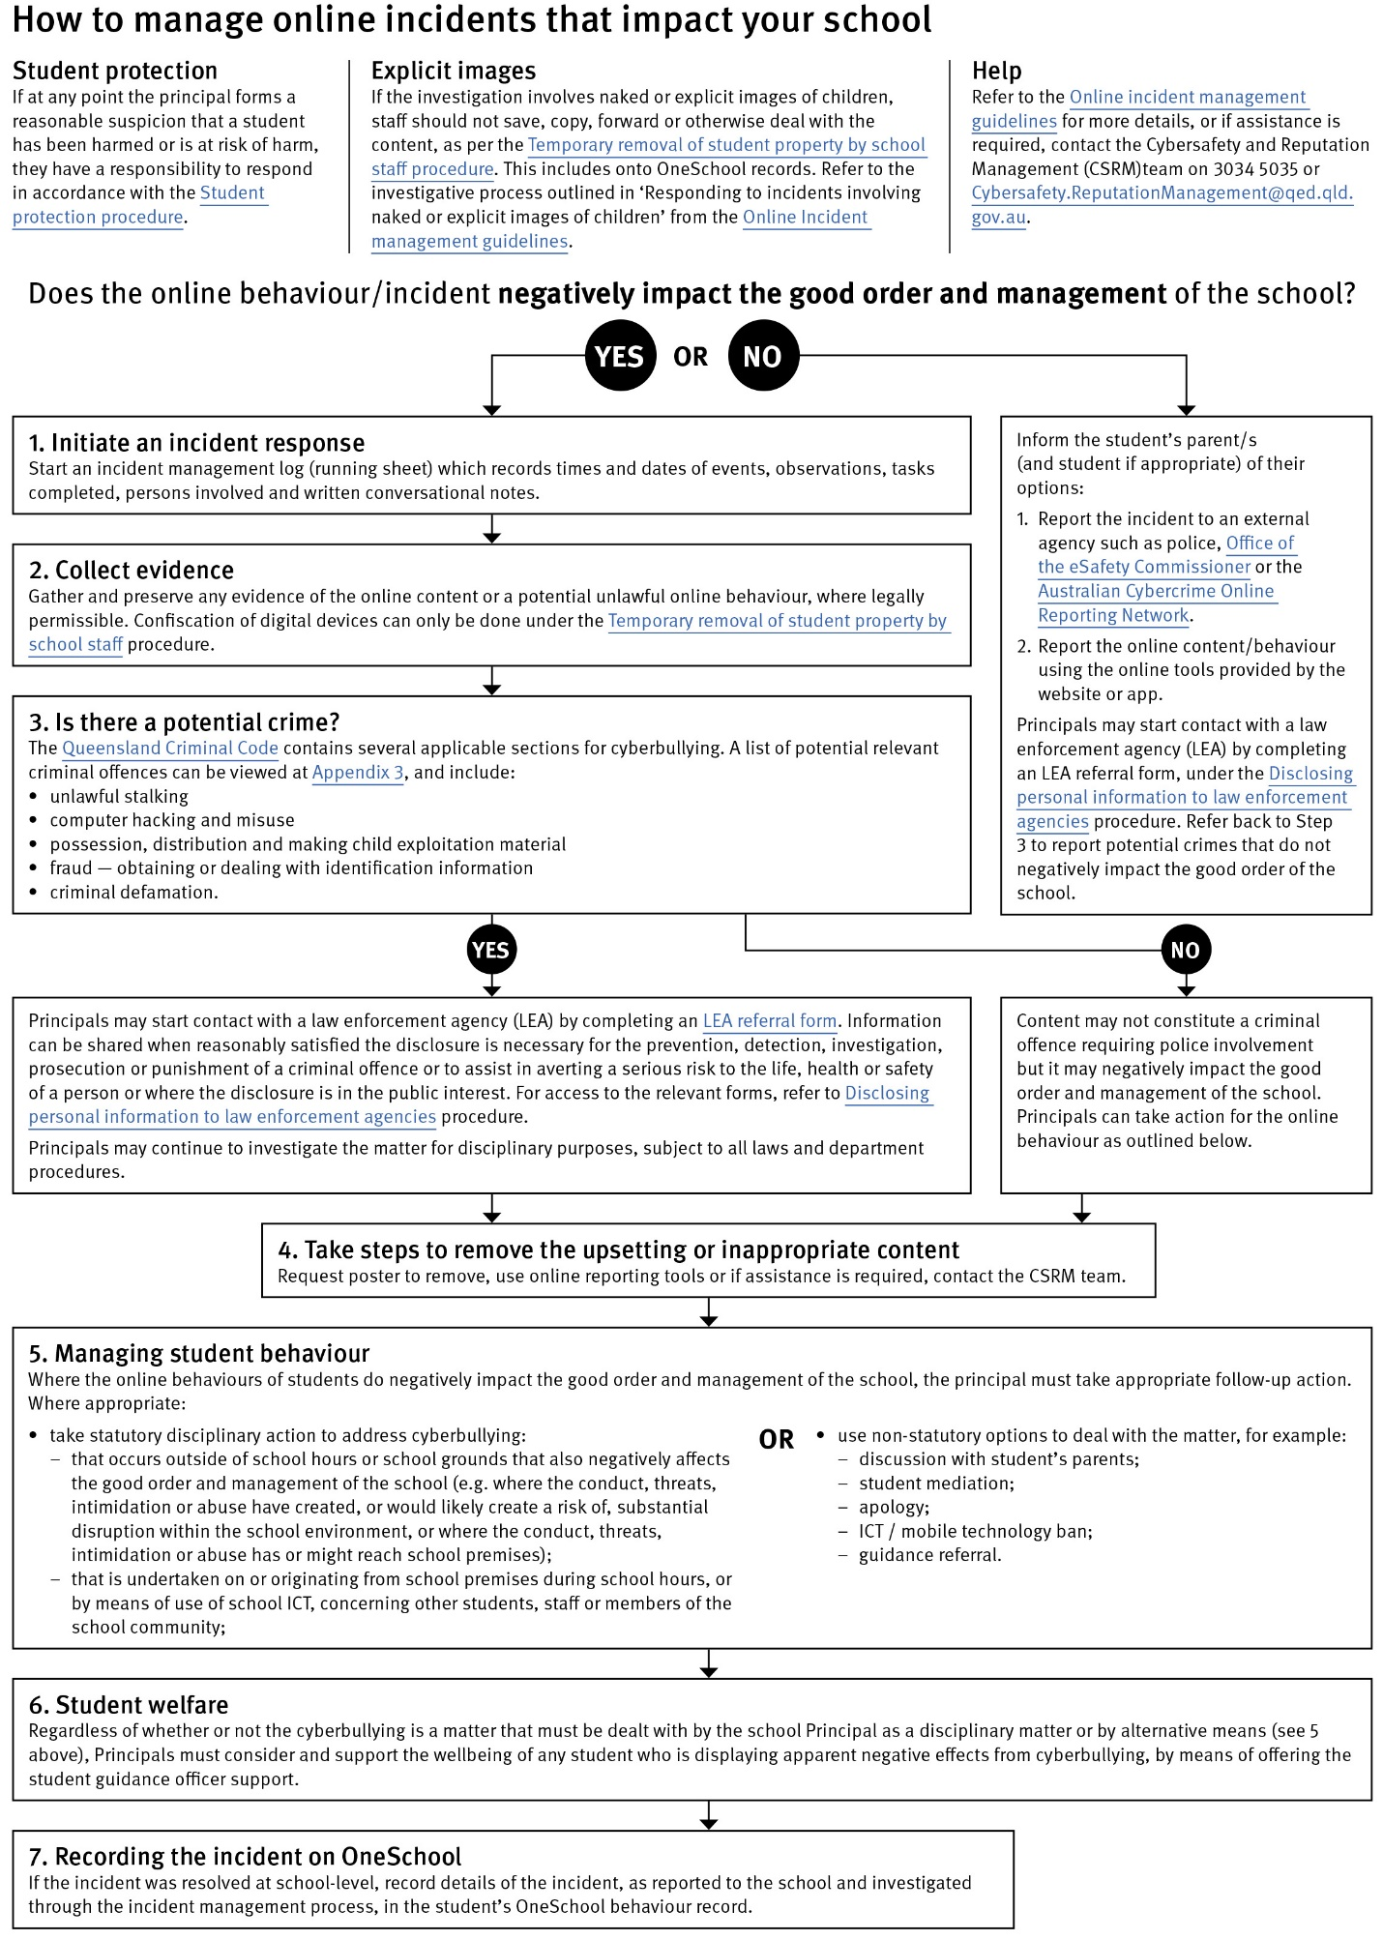

Restrictive Practices (Mandated)

In some very rare situations, where there is immediate risk of physical harm to the student or other people, and when all other alternative strategies have failed to reduce the risk, it may be necessary for staff to use restrictive practices.

The use of restrictive practices will always be as a last resort, when there is no other available option for reducing immediate risk to the student, staff or other people. Restrictive practices are not used for punishment or as a disciplinary measure.

The department’s Restrictive practices procedure is written with consideration for the protection of everyone’s human rights, health, safety and welfare. There are six fundamental principles:

- Regard to the human rights of those students
- Safeguards students, staff and others from harm
- Ensures transparency and accountability
- Places importance on communication and consultation with parents and carers
- Maximises the opportunity for positive outcomes, and
- Aims to reduce or eliminate the use of restrictive practices.

Very rarely restrictive practices will be planned and staff will employ, when necessary, pre-arranged strategies and methods (of physical restraint/ mechanical restraint/ clinical holding) which are based upon behaviour risk assessment or clinical health need and are recorded in advance. The use of planned strategies will only be where there is foreseeable immediate risk consistent with the Restrictive practices procedure.

Seclusion will not be used as a planned response and will only be used in serious circumstances for managing an unforeseeable situation in an emergency. It will be used for the shortest time possible and in a safe area that presents no additional foreseeable risk to the student. In such emergencies, a staff member will observe the student at all times and seclusion will cease as soon as possible.

Following the use of any restrictive practice, a focused review will help staff to understand how they responded to the risk in any incident that involved the use of a restrictive practice. Staff will consider whether there are other options for managing a similar situation in the future. This strategy works well for reducing the use of restrictive practices.

All incidents of restrictive practices will be recorded and reported in line with departmental procedures.

This section of the Student Code of Conduct should include examples of when your school intends to use any restrictive practices. Please refer to the Restrictive practices procedure in preparation of this element of the document.

Critical Incidents (Mandated)

It is important that all school staff have a consistent understanding of how to respond in emergencies that seriously endanger students or others. This consistency ensures that appropriate actions are taken to ensure that both students and staff are kept safe.

A critical incident is defined as an occurrence that is sudden, urgent, and usually unexpected, or an occasion requiring immediate action (e.g. in the community, on the road).

This section of the Code of Conduct must detail the actions staff and students will take in the event of a critical incident.

Related Procedures and Guidelines (Optional)

These are related procedures or guidelines which school staff use to inform decisions and actions around matters associated with students wellbeing, behaviour and learning. This may include reference to

- Cancellation of enrolment
- Complex case management
- Customer complaints management policy and procedure
- Disclosing personal information to law enforcement agencies
- Enrolment in state primary, secondary and special schools
- Hostile people on school premises, wilful disturbance and trespass
- Inclusive education
- Police and Child Safety Officer interviews and searches with students
- Restrictive practices
- Refusal to enrol – Risk to safety or wellbeing
- Student discipline
- Student dress code
- Student protection
- Supporting students’ mental health and wellbeing
- Temporary removal of student property by school staff
- Use of ICT systems
- Using mobile devices
Resources (Optional)

This section of the plan should describe or link to government resources and supports that may assist staff, students and parents in the area of student behaviour or wellbeing.

Conclusion (Optional)

Include a brief conclusion about the purpose of the Student Code of Conduct, its role in the whole school culture and support approach. A section on how parents can progress a complaint should be incorporated, referring to the Department of Education’s Customer complaints management framework, policy and procedure.

